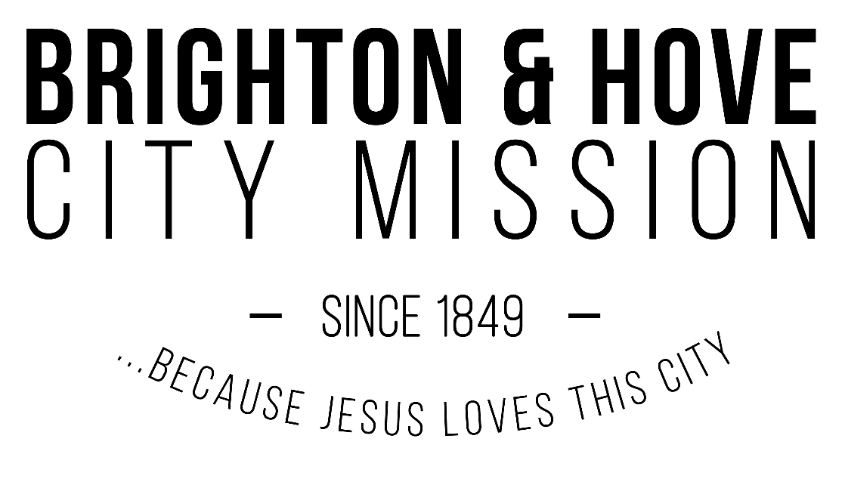

**Application for Employment with Brighton and Hove City Mission (BHCM)**

**Position applying for:**

This application does not imply or constitute a contract or binding commitment on behalf of BHCM or the applicant.

Before completing this form, please refer to our Equal Opportunities Policy, Ethos Statement, and Doctrinal Basis (to be signed and dated) at the end of this document. When completed and signed, the form should be sent directly to the Office Manager via email: [office@bhcm.org.uk](mailto:office@bhcm.org.uk). If appropriate, it will form the basis of an interview at a mutually agreed time and place.

***If additional space is required to answer a question, please attach additional sheets, numbered accordingly.***

**1. Full Name:**

1. **Address:**
2. **Phone Number:**
3. **E-mail address:**

1. **Please give details below of your employment history, including your present employment and the name and address of your present employer:**

*(Please indicate if you would rather a reference was not taken up with your present employer at this stage.)*

1. **Please give details of your education, including any theological training, or any other training relevant to this job:**
2. **Please give a brief account of how you became a Christian:**
3. **What voluntary Christian service, if any, have you had in the past?**
4. **What church and denomination are you a member of?**
5. **What experience have you had of working with other denominations?**
6. **Do you fully accept the Doctrinal Basis, Equal Opportunities and the Ethos Statement of the Brighton and Hove City Mission?** (enclosed)
7. **Please give names, addresses and telephone numbers of two people, other than your present employer, from whom references can be obtained. One should be your current Church Leader/Pastor/Elder:**
8. **Please give your reasons for wanting to work with and for the Brighton and Hove City Mission.**
9. **What skills/experience would you bring to this job?**
10. Under the Rehabilitation of Offenders Act 1974, ex-offenders do not have to disclose criminal convictions when applying for most jobs if their conviction is spent. This post, however, is considered exempt from that legislation due to the nature of the work, which is with people considered vulnerable. You must therefore give details of **any** criminal convictions. This information will be treated with the utmost confidence.

**Do you have any criminal convictions, cautions, or bind overs?**

**If so, please give details to the Office Manager via email: office@bhcm.org.uk.**

*Here at Brighton and Hove City Mission (BHCM) we take your privacy seriously and will only use your personal data in ways that you consent to it being used. Please note that by signing this form, it is understood that you consent to BHCM processing and retaining the information given on the form for as long as is necessary.*

**Print:**

**Sign:**

**Date:**

**Any successful candidates will be required to carry out a DBS check** (if you have a criminal record, this will not necessarily hinder you obtaining a position, but will be discussed with you).

EQUAL OPPORTUNITIES POLICY

The Equal Opportunities Policy of Brighton and Hove City Mission (BHCM) reflects both the statutory Objects of BHCM, and the spirit and intention of legislation that outlaws discrimination. BHCM recognises that people from different backgrounds can bring fresh ideas and skills. It values diversity and welcomes interest from all sections of the community. It is committed to build and reinforce a culture where people value each other and treat each other with dignity and respect.

In terms of our ministry to those we seek to serve, BHCM will not discriminate or treat any individual less favourably on the ground of gender, marital status, race, colour, nationality, ethnic origin, disability, age, or sexual orientation.

BHCM aims to ensure that people with disabilities are given equal opportunity to enter employment or to join us as trustees or volunteers. In doing so, we will fully consider making reasonable adjustments to working practices, equipment, and premises to ensure that a disabled person is not put at a substantial disadvantage due to their disability. In addition, should someone already employed by BHCM become disabled, every effort will be made through reasonable adjustment, retraining or deployment to enable them to remain in the service of BHCM.

Entry to employment with BHCM, and promotion or change of post for paid staff, or the equivalent for trustees or volunteers, is determined solely by personal merit and ability relevant to the statutory Objects of BHCM.

BHCM is committed to keep requirements and practices under review and to take action, where necessary, in order to facilitate the recruitment, involvement, and development of Paid Staff, Trustees and Volunteers from all sections of the community. We welcome difference and recognise that action may be needed to give everyone a chance to contribute on equal terms, within the constraints set by the statutory Objects of BHCM.

The Objects of BHCM commit to promoting the advance of the Christian gospel: accordingly, as an Evangelical Christian Organisation, all staff in posts that are central to the fulfilment of our statutory objects are required to demonstrate a clear commitment to the Christian faith.

Sexual and racial harassment are forms of discrimination on the grounds of a person’s gender or race: this and other harassment is totally unacceptable to BHCM and any such behaviour is considered a disciplinary offence. All allegations of harassment are treated seriously and all practicable steps are taken to prevent the behaviour continuing.

**ETHOS STATEMENT**

The Ethos Statement of Brighton and Hove City Mission (BHCM) is rooted in the teaching and example of Jesus Christ. It is His love which compels us to serve others, putting their needs first.

BHCM exists for the advancement of the Christian gospel, both directly and working alongside local churches, and for the relief of poverty, sickness, and distress in Brighton and Hove, and the surrounding area.

The ethos of BHCM is our motivation for all the work carried out within our various projects and ministries. Everything that BHCM strives to achieve is inspired by the message, life, and example of Jesus, through which God’s unconditional love for all people is expressed, in particular His concern for the poor and disadvantaged.

This ethos is worked out through our ministry to those in need, and whom we seek to serve, irrespective of their religious beliefs, race, colour, nationality (including citizenship), ethnic or natural origins, gender, sexual orientation, marital status, political affiliation, disability, or age. The inspiration and faith shared by our trustees, employees, and volunteers compels us to serve others as Christ would have done, and it is this common faith which directs and influences our relationships within the organisation, amongst those we seek to serve, and towards external agencies.

For this reason, we expect our Christian teachings and beliefs to be respected and owned by our trustees, employees, and volunteers.

The objects of BHCM commit to promoting the advance of the Christian gospel; accordingly, as an Evangelical Christian organisation, for all staff and volunteers in posts that are central to the fulfilment of our statutory objects it is an occupational requirement that those in post are required to demonstrate a clear commitment to the Christian faith.

Our ethos will also inevitably be the base from which all future developments and new initiatives within our various ministries and projects will be formulated.

**Doctrinal Basis**

**WE BELIEVE IN...**

1. The one true God who lives eternally in three persons—the Father, the Son and the Holy Spirit.
2. The love, grace and sovereignty of God in creating, sustaining, ruling, redeeming and judging the world.
3. The divine inspiration and supreme authority of the Old and New Testament Scriptures, which are the written Word of God—fully trustworthy for faith and conduct.
4. The dignity of all people, made male and female in God's image to love, be holy and care for creation, yet corrupted by sin, which incurs divine wrath and judgement.
5. The incarnation of God’s eternal Son, the Lord Jesus Christ—born of the Virgin Mary; truly divine and truly human, yet without sin.
6. The atoning sacrifice of Christ on the cross: dying in our place, paying the price of sin and defeating evil, so reconciling us with God.
7. The bodily resurrection of Christ, the first fruits of our resurrection; his ascension to the Father, and his reign and mediation as the only Saviour of the world.
8. The justification of sinners solely by the grace of God through faith in Christ.
9. The ministry of God the Holy Spirit, who leads us to repentance, unites us with Christ through new birth, empowers our discipleship and enables our witness.
10. The Church, the body of Christ both local and universal, the priesthood of all believers—given life by the Spirit and endowed with the Spirit's gifts to worship God and proclaim the gospel, promoting justice and love.
11. The personal and visible return of Jesus Christ to fulfil the purposes of God, who will raise all people to judgement, bring eternal life to the redeemed and eternal condemnation to the lost, and establish a new heaven and new earth.

**Name: _____________________________________**

**Sign: _____________________________________**

**Date: _____________________________________**