

**Housing & Support Officer (HSO)**

Thank you for showing an interest in this position.

This is a paid role on a part-time basis, three or four days a week (22.5 hours per week).

**Lifeline Harrogate - Background**

Lifeline formed in the summer of 2012 as a limited company and then quickly also became a charity. Our first 3 bed house opened for men only in February 2013.

We now have seven houses and so can support 18 men and 3 women. Lifeline can buy houses through our partnership with Green Pastures, a national Christian social enterprise. Our residents have already enjoyed over 47,000 nights of accommodation in our houses, safe, secure and living in a supported environment.

In our November 2024 annual resident questionnaire, a resident said

**“I dread to think where I would be now if it wasn’t for Lifeline – words cannot explain”.** Many say to us “you are a lifeline for me just as your name says”! When this is the resident that you are supporting saying this, well you can only imagine the levels of job satisfaction we experience!

There are also some real hidden extras to being a support worker with Lifeline such as

* A monthly outing with residents to a place of interest – all expenses paid
* Fortnightly lunch club with residents
* Croner HR Employee Assistance Programme
* Working in a close knit and supportive team
* Daily devotions
* Quarterly retreat day
* Staff training with bursaries towards examination/study qualifications
* Mileage and all reasonable expenses paid
* Company visa card so that expenses can be minimised

Lifeline is a Christian Charity and so due to the strong Christian ethos which underpins the values of Lifeline and its service delivery there is a genuine operational requirement for the postholder to be a practising Christian.

**Requirements of the role of** **Housing & Support Officer (HSO)**

Lifeline Harrogate supports vulnerable adults by transitioning them from a hostel type environment to independent living with support, with the aim of progressing them to fully independent living.

The role of HSO involves house visits to our houses and meeting the residents, usually on at least a twice weekly basis, to progress them through an agreed support plan. The role also involves working closely with other members of Lifeline, whether that be the Chief Executive, other paid members of staff, Trustees or Volunteers.

The role encompasses two main elements:

**Housing Management** – working with the residents to enable them to successfully manage their stay with Lifeline. This part of the role is in effect like being a landlord. That means ensuring that the property is well managed and that any issues are flagged up so that they can be added to our repairs and maintenance log

* Providing housing related advice to residents
* Liaising with other agencies
* Managing voids
* Working with residents to ensure the service charge is made
* Providing Sign-Up advice for residents moving in
* Ensuring Health and Safety standards are met in the house
* Performing weekly safety checks in the house
* Conducting monthly house meetings to ensure that all residents are aware of the fire safety issues and would know how to work together in the event of a fire. Those meetings also to address issues around resident harmony

**Care Support or Supervision** – providing additional support to help Lifeline’s residents to make progress in their lives by addressing any barriers to fully independent living. Examples (ie not a full list) of this are:

* Assessing the needs of the individual seeking accommodation
* Working to address issues surrounding independent living skills
* Providing advice and support with any issues of substance misuse
* Helping residents develop their relationships and expand their social network
* Supporting residents with their physical, mental and emotional health
* Providing spiritual support when appropriate
* Promoting healthy living to our residents
* Helping with budgeting and finance/debt issues
* Devising a bespoke meaningful activity programme for each of your residents
* Work with the resident’s CV and future employment related issues
* Encouraging residents to partake in social activities that Lifeline provides
* Assisting residents to undertake an agreed part in keeping the house clean, tidy and presentable
* Transitioning the individual to full independence

**What does a week look like for a Lifeline resident?**

For you to be more aware of how we operate these are some details of what life might look like for a Lifeline resident and how you might be involved.

We are very much of the view that routine is always good. We are very intentional then of creating a schedule of activities that residents can enjoy and be challenged by. That will of course be different for everyone and will involve some signposting to other agencies. We set an expectation that they will do *at least* 10 hours of meaningful activity which might encompass volunteering, employment, education or training, or attending support groups.

We do provide a baseline of Lifeline activities, and these are as follows:

* A weekly ‘Peer Support Group’
* A fortnightly lunch club
* Art therapy classes with Georgie fortnightly
* Monthly outings to places of interest (eg seaside, go-karting, Yorkshire Wildlife Park, walks, etc) – see photo below of our February ’25 outing which was to York with a visit to the train museum, lunch and then a walk round the city to see the famous sites

* A weekly education class with North Yorkshire Adult Learning or internally with Lifeline
* A weekly sit down with you as the residents dedicated support worker to work through highlighted issues in the resident’s support plan
* Daily access to the Hydro. We have two passes for all activities. Sometimes we do accompanied visits
* Receiving a delivery of fruit and vegetables from ‘Roots and Fruits’ and meals from ‘Cook’

This is a very committed approach and involves massive amounts of effort and dedication from our wonderful staff. If we are to see lives change then we need to invest into people, and this is how we have seen lives change at Lifeline, so we know it works.

Some stats for Lifeline as at March 2025;

* 142 people housed and supported
* 71 leavers have left to live independently (60% of leavers)
* 76 residents have found paid work (55% of leavers)
* 101 residents have engaged in regular meaningful activity (73% of all residents)
* 52 residents have advanced in their journey out of addiction
* Average stay with Lifeline is 335 nights
* Over 93% occupancy of our rooms since we began housing people in February 2013

**Additional portfolios**

Several of our HSO’s also have an additional ‘portfolio.’ These are currently

* Running the weekly ‘Peer Support Group’
* Providing weekly educational classes for residents – this is now a vacant role
* Organising and planning the wellbeing days out
* Providing move-on support for those residents when they leave Lifeline– this is now a vacant role

Additional hours are worked out to cover these activities. Could it be that we could use your unique skills to develop something new to enhance the lives of our residents?

**Commitment and perseverance**

The path to a life fully restored back into the community can be a long and winding road. Steps forward can also be quickly accompanied by backward steps. Our experience is that this is rarely a smooth transition. We try and create a ‘Lifeline family community’ which enables people to prosper more easily as they realise that they are valued and appreciated for who they are. All of this takes much character, commitment and perseverance.

The Bible says that ‘love covers over a multitude of sins’ and so whilst we are not perfect either, we can show love to the people we are housing and share their burdens as we work with them to rebuild their lives. As mentioned earlier this is done without any expectations to timescales or outcomes, just an initial commitment from them to go on a forward-facing journey with us.

**Training**

You will be given full training before undertaking any visits to the Lifeline properties. Initial visits will be accompanied.

**Application Form and CV**

A short Lifeline application form needs to be completing with two personal referees and your CV attached. This is on the website.

**Salary**

HSO: £25,956 FTE - with increases (decided by the Trustee board) each April

**Requirements of the HSO**

|  |  |  |
| --- | --- | --- |
| **Quality** | **Essential** | **Desirable** |
| Understanding of the need to be non-judgemental | Essential |  |
| Not to engage in any discrimination against service users on the basis of age, racial ethnicity, sexual orientation or gender. | Essential |  |
| Always being willing to treat others as you would like to be treated | Essential |  |
| Ability to be flexible to accommodate changing needs of the role | Essential |  |
| A good listener | Essential |  |
| Ability to work as a team-player | Essential |  |
| Ability to empathise with people from different backgrounds | Essential |  |
| An operational requirement to be a practising Christian due to the values of Lifeline and its service delivery | Essential |  |
| Clear about the role of HSO (can be achieved through training) |  | Desirable |
| Some experience of working with homeless or vulnerable adults |  | Desirable |
| Accurate and consistent record keeping | Essential |  |
| Good IT Skills |  | Desirable |

**Lifeline Quotes and Photos**

This really is a special job. We are not just saying that because as you will see below that is what our residents say, and so you will be playing a part in this amazing move of God, so we wanted to provide a more intimate view of who we are and what we do.

To give you a flavour of this role please find attached some quotes from our annual resident questionnaires and some photos of outings they we have.

The person leaving the post, hence creating one of these vacancies, has said **“It has been a privilege to have supported so many different residents and to do this job has been one of the biggest blessings of my life.”**

**(the quotes below are not linked to the photos)**

**Quote: *“I feel like I have or am having the time to find out who I am and who I want to be as a person”***

**Photo: August ’24 trip to Brimham Rocks**



**Quote: “*Has given me confidence to talk openly with people and support workers at Lifeline”***

**Photo: Fish and Chips on the beech at Saltburn by the Sea in September ‘24**

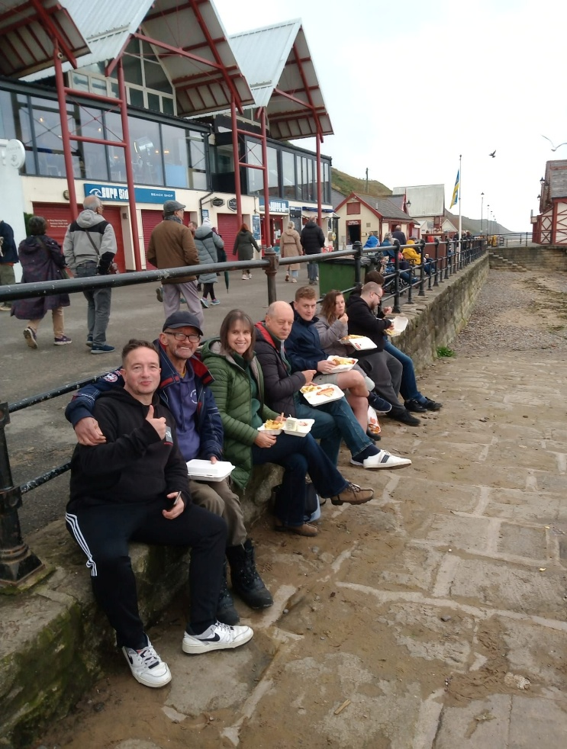

* **Quote: *“Lifeline has very much saved my life and I will be forever grateful.”***
* **Photo: Go-karting at Tockwith York**

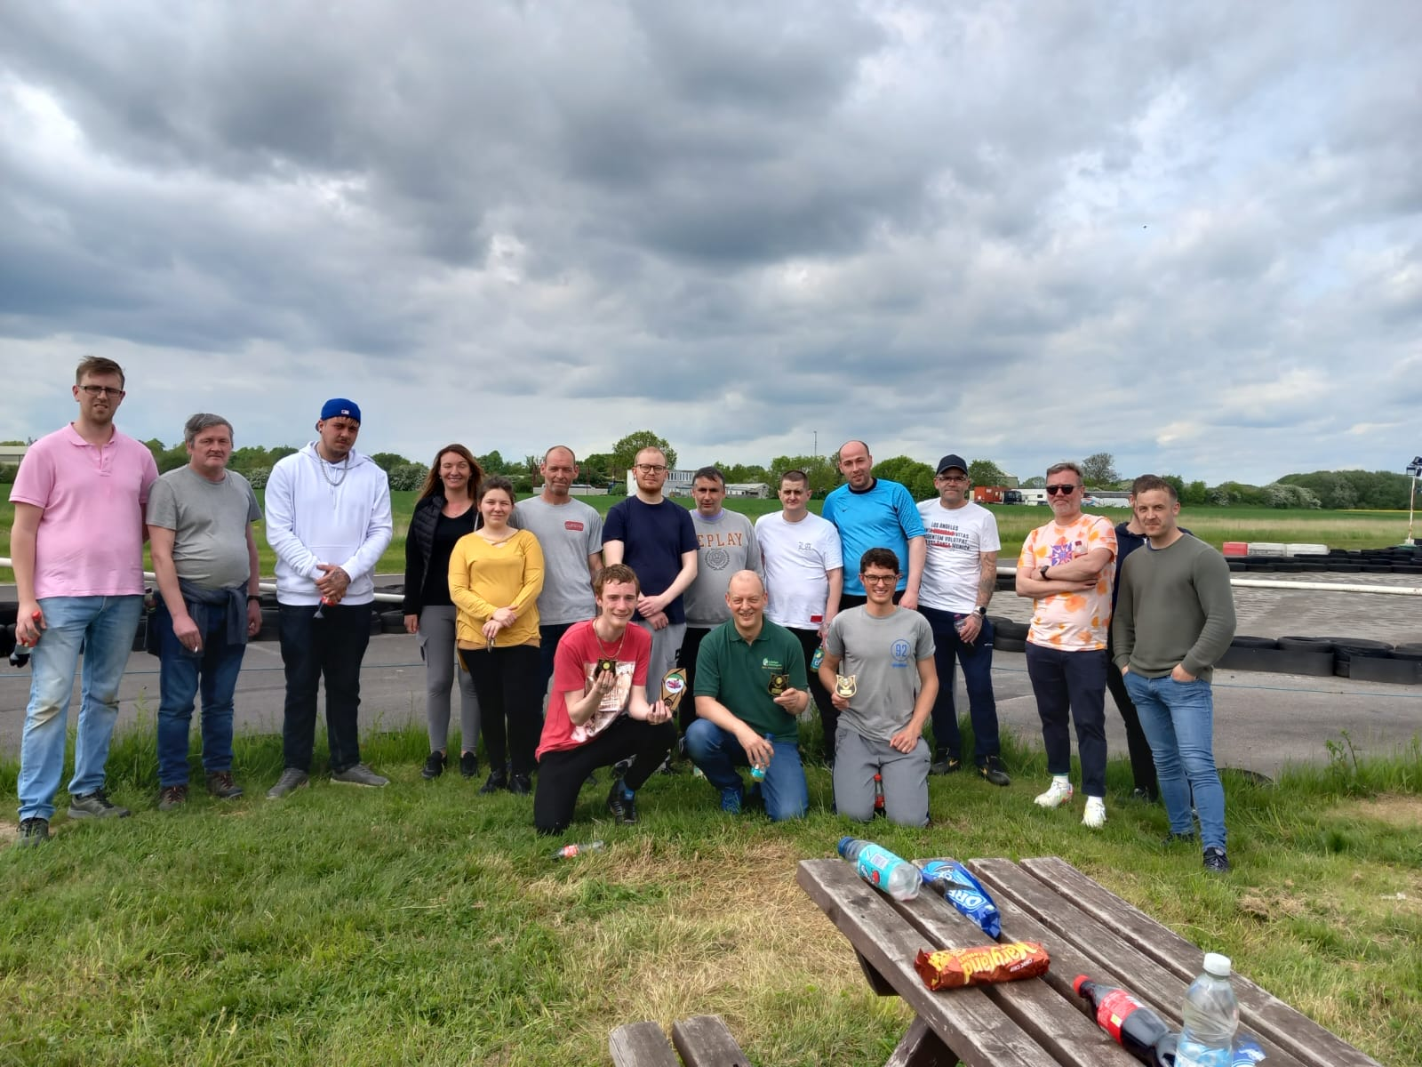

* **Quote: *““Made a massive difference to me. I had cut everybody off and was isolated and pretty hopeless. You cared and went above and beyond to help me pause and consider myself – really made a remarkable difference to me – not just the practical things – housing (homing) me, feeding me. You gave me hope and faith in myself and others. Good things then started to happen. The support you gave me has changed my life.”***
* **Photo: Trip to Micky Hammonds racing stables in Middleham, North Yorkshire**
* 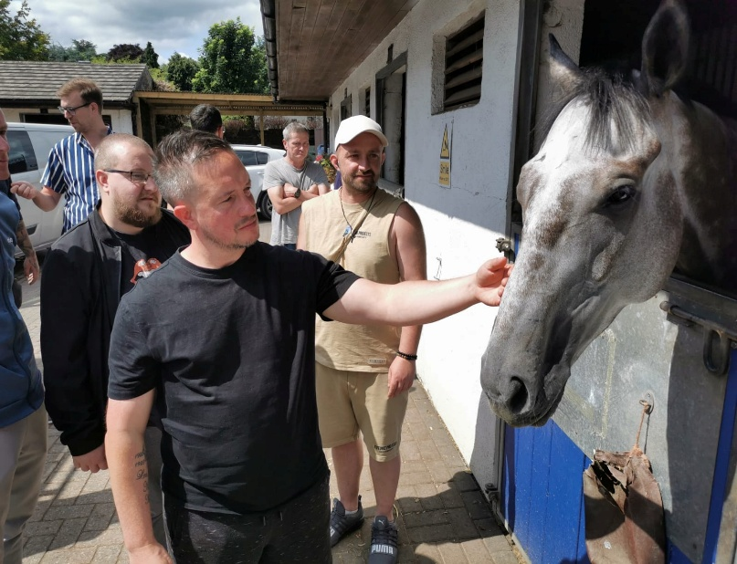

**Quote: “Lifeline has helped me with every aspect of my life not only the addiction side of things. My support worker has really helped me deal with emotions I struggle to deal with myself.”**

**Photo: Our first residential overnight stay in October 24 to Thirsk**

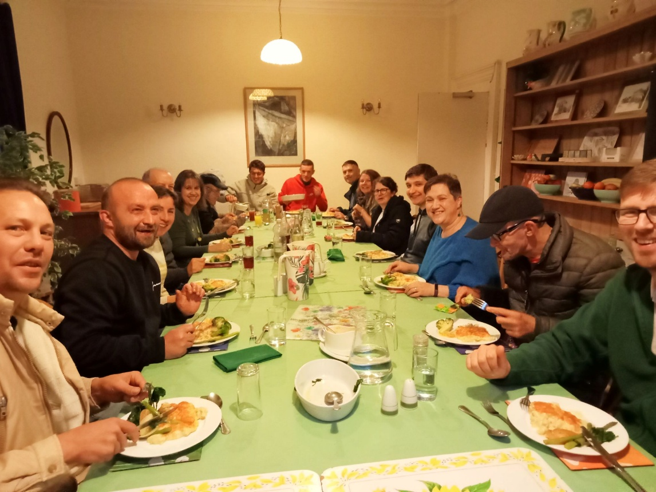

I hope this gives you some flavour of the amazing times we have, and what a privilege it is to work with people at their point of utmost need.

*1 John 317 If anyone has material possessions and sees a brother or sister in need but has no pity on them, how can the love of God be in that person?*

Carl Good. CEO. May 25.