**PROFILE OF EPSOM METHODIST CHURCH**

# Epsom Methodist Church “EMC” is very close to the centre of Epsom (about 100m from the High Street) and so is very conveniently situated for events involving the Epsom Community. Our mission statement commits us “To respond to God’s love in Christ for everyone - by being a real focus in the town for Christian teaching, worship and care.”

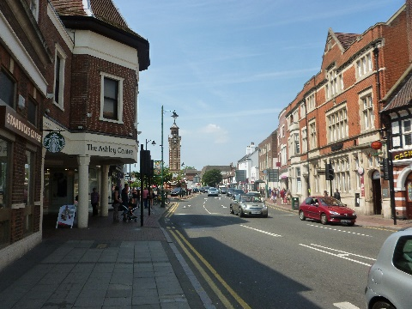 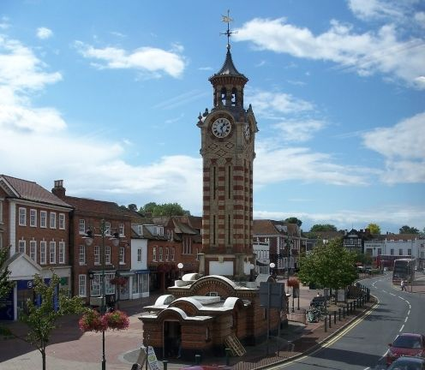 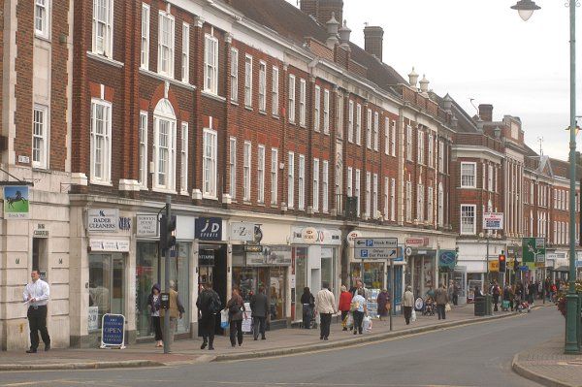

EMC is a large Methodist Church with four services every Sunday (combined attendance 450+):

* 9am: Traditional service with a congregation of around 40 to 50 adults attending
* 10.30am: More contemporary service including children’s work with around 50-70 adults and children attending
* 2pm: Chinese Services (CCEMC) and International Congregation service

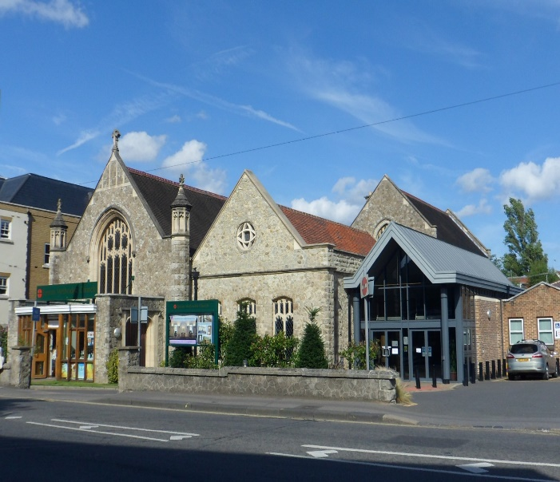

EMC, like many other Churches, took a while to recover from the restrictions of the Covid pandemic but has now seen a return to pre-pandemic attendances at Sunday services. All services continue to be offered as both live and ‘streamed’. However, the most significant development has been in the number of people coming through our doors during the week for a variety of church and community run activities, particularly our children’s events. There are several other signs of renewal and encouragement that are challenging us to new work.

In the summer of 2022 after a review of staffing requirements, EMC employed a Mission and Outreach Pastor to develop our pastoral care, our worship leading and Children’s ministry. After a successful 2 years he has now moved on and this has enabled us to modify the role with a changed emphasis – which is reflected in the Job Description.

There is further information on EMC’s website ([www.epsommethodistchurch.org.uk](http://www.epsommethodistchurch.org.uk)) but in summary key features of Church life include:

**Ministry Team:** The current Ministers are the Rev Catherine Hutton and Rev Ung Soon Nguang (responsible for the Chinese Church). A Supernumary Minister, the Rev Gill Long, assists one day a week with pastoral work.

**Pastoral Work**: There is an active Pastoral Committee/Group which meets every Monday morning to discuss visiting and supporting our members.

**Uniformed Groups:** the Uniformed Groups associated with EMC are some of the most active in the UK, including Beavers, Rainbows, Cubs, Brownies, Scouts, Guides, Explorer Scouts and Rangers. We are working to establish closer links with these groups.

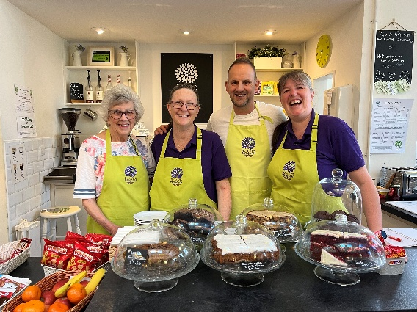

**Coffee Shop:** Since April 2017 a Coffee Shop “Roots” uses our flexible worship area to provide a thriving Community Café on weekdays from 9am to 2pm. It offers a friendly safe space for Church members and the community to meet and talk and provides many opportunities for support and outreach.

**Warm Wednesdays:** For the last three years, with the help of Roots, we have opened up our worship area every Wednesday to provide a Warm Space where people can can come and stay as long they like, have a hot drink, soup and a roll at lunchtime and a hot meal at tea time. The latter part of the day takes takes the form of an after-school club with parents coming with their children to participate in craft activities before they eat together. Many of those who come just enjoy the welcome and the friendship but we also provide help with dealing with utility companies, emergency financial support and warm winter supplies of clothing and other goods. Around 100 people attend for some or all of the day and we serve an evening meal to around 40 to 80 people.

**Music:** At our 9.30am Sunday service traditional hymms are accompanied by the organ (live or recorded). At 10.30am we have a small band of volunteer musicians and music is generally more contemporary.

**House and other Groups:** There are five active house/life groups, and we are looking to start new groups. These groups continued via ‘Zoom’ during lockdowns and some have continued to meet more regularly this way. There are several other groups and activities which we are seeking to develop further.

**Welcome Club**: - this group meets twice a month: a drop-in session offering friendship and sharing; and a more structured session with a focus for discussion.

**Older People:** For the last five years during August EMC has run ‘Holiday at Home’ attended by older members of EMC and the local community. The Church also provides Christmas entertainiment for older people. In addition, a Faith in Later Years (FILY) group meets monthly with a newspaper and a bible to discuss what’s in the news from a Christian perspective.

**Outreach:** Our Mission and Outreach pastorestablished a Mission Forumto challenge the Church to think about the focus of its mission and how it related to the local community. This resulted in setting up small groups, a successful film club that is meeting monthly and the piloting of a Forest Church inititiave. The Church has also been a lead player in the ‘Hope into Action’ project in Epsom that has funded and provided accommodation for homeless people.

**Finances:** EMC is reasonably well endowed financially with healthy reserves and the Church is continuing to invest in its development. Recent projects include the installation of solar panels and the complete renovation of our community kitchen and community hall.

**Web site:** <http://www.epsommethodistchurch.org.uk> is managed in-house and is an online resource, showcasing many church activities. This is run in parallel with a weekly newsletter and prayer bulletin that are emailed to Church members on a Friday evening and Monday morning respectively.

**Staff:** The office is managed part time (Monday to Thursday) by our Operations Manager, Sarah Meech, who oversees the property and lettings as well as having oversight of many other aspects of running our Church. There are two part time assistants who provide support across a range of activities including updating the website. The Church lets out its rooms to more than 30 different local groups and derives significant income from this activity. We are looking to promote events at the Church more actively to these groups.

**Children and Families work**

On weekdays EMC has a variety of activities and groups for Children and Families from a support group for new parents, Mother and Toddler groups, a vibrant Early Years nursery and a Family Centre. The Family Centre offers support to parents and children through providing workshops and courses for parents on practical issues such as cooking on a budget, speech therapy, first aid and a holiday lunch club.

On Sundays - our current activities include:

* KidZone meets every Sunday where attendance has fallen recently and we need to appeal more to families which we are attempting to address through several initiatives.
* Special family orientated services at Harvest, Remembrance and Easter.
* Christmas events for children and families include an under-5s Nativity Praise service and a Family Nativity Festival linked to our Christingle service.