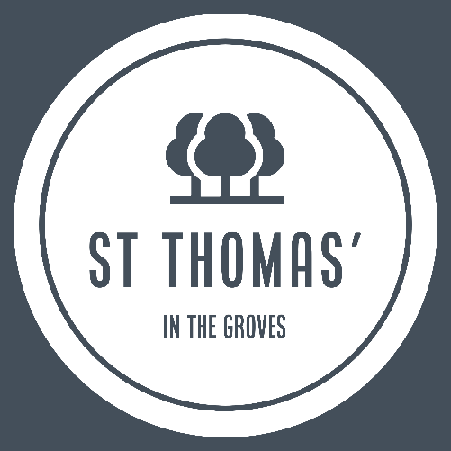
We are hiring! Church Administrator wanted.

Do you have a heart for ministry and strong organisational skills?

St Thomas’ in the Groves, York is looking to recruit a part time Administrator to join our team of staff and volunteers. We are a growing church with a diverse congregation and many links to the local community. As we grow, we need help to organise well and provide support to our ministry leaders as their roles expand. Therefore, this is a significant role with managerial responsibilities included.
The post is for 18 hours a week. The salary is £26,000 pro rata.
These hours are negotiable and flexible and may include some Sunday/ evening working. You will work from the church building and from home.

There is an occupational requirement under S7 of the Employment Equality (Religion or Belief) reg 2003 that the postholder is a committed Christian.
Job specification and application form are available here
To find out more about St Thomas’s, visit us at www.stthomasyork.org.uk
Closing date for applications is May 30th 2025.
Interviews will be held w/c June 9th 2025

