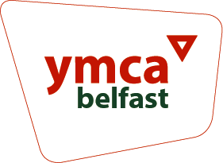
Head of Operations

Supplementary Questions – Please include examples in your responses.
Tell us about your relevant third level and/or professional qualification (150 words)
Tell us how you meet our essential criteria through past experience? (400 words)
Tell us how your skills would support you in this role? (300 words)
Describe how you would develop an operations strategy for Belfast YMCA (300 words)
Desirable Criteria
(In the event of a high number of applications we may apply the desirable criterion as part of the selection)
Tell us about your experience of managing an operations team or function in another organisation (200 words)
Tell us about your experience of managing change and improvement projects (200 words)

Please complete and return along with your CV (max 3 sides) and Monitoring Form to jobs@belfast-ymca.org by Monday 20th May at 10am

