Growing Younger Enabler for Youth
RECRUITMENT INFORMATION
In this pack you will find:

- Introduction
- Growing Younger in the Diocese of Carlisle
- About the role
- Job Description and Person Specification
- Key links for more information

Introduction
This is a significant, hope-filled but challenging time for the Church of England in Cumbria.

Alongside our ecumenical partners we have recently renewed our vision and strategy, God for All, as we look to the next decade.
The vision centres around four key values which frame our priorities:
1. Follow Daily:
We will help each other to follow Jesus more closely, seeking to grow as his disciples in all aspects of life, both corporately and as individuals
2. Care Deeply:
We will listen to our local communities and respond in loving service, seeking to transform injustice, challenge oppression and pursue peace & reconciliation.
3. Speak Boldly:
We will share our faith in Jesus Christ in everyday ways, seeking to connect with everyone, especially those currently unrepresented in our churches. We’ll do this in both time-honoured & pioneering ways.
4. Tread Gently:
We will strive to safeguard the integrity of God’s creation, seeking to sustain and renew the life of the earth.

These are the building blocks that help us define our core purpose as Church and our main tasks.

The Diocese of Carlisle covers (more or less) the County of Cumbria and is part of an ecumenical covenanted partnership with 3 other denominations - the United Reformed Church, the Methodist Church and The Salvation Army. The county is divided into 34 Mission Communities; local ecumenical groupings of parishes and other churches. Mission Communities bring together churches in a geographical location to share ministry and work together in mission and outreach.

We have recently been awarded funding from the national ‘People Capacity Funding’ to enable the recruitment of key roles to maintain momentum with the implementation of God for All from 2024-2027. These roles will enable us to continue our development and preparation for our planned application to the Church of England’s Strategic Mission and Ministry Investment funding in 2025 for The Cumbrian Way, a 5-year programme of work to help implement God for All at a local level through our Mission Communities. The Cumbrian Way aims to see significant cultural shifts in, and missional impact for, our churches across the diocese and county. We are now looking to recruit a Growing Younger Enabler for Youth to join us in delivering this work now and in the years ahead.

Growing Younger in the Diocese of Carlisle
One of our strategic areas is Growing Younger. As in so many places, our congregations are generally getting older and smaller. In the ten years from 2010 to 2019, numbers worshipping on Sunday in the Diocese fell by 27% from 13,100 to 9,500. This decline has happened across all sizes of churches. Church attendance and membership in our less affluent urban areas is particularly low.

However, over the last 10 years the diocese has invested in Network Youth Church (NYC) as a response to the challenges we are facing. Please note the website is currently being updated. NYC is a way of doing and being church that helps young people discover life in all its fullness, explore the Christian faith, the skills they need to live, learn, work, and interact successfully with other people, and engage with the wider world. Between 2016 and 2022, NYC has grown in core attendance by 33%. There are almost 2000 young people who interact with NYC, and around 800 core(regular) members.

NYC is now at the point of needing resources and strategic leadership to develop it further in structure, governance and sustainability.

We also have a strategic objective of growing younger in our leadership. Currently just under half of our clergy could potentially retire in the next 10 years, and only 9.4% of our ordained leaders are aged under 40. In 2022, the diocese relaunched its Intern Scheme, the Northern Young Leaders Project. This scheme is part of the Ministry Experience Scheme for the Church of England. We also partner with the Norwegian Mission Society to accept interns from across the globe. Working in placement churches, this year long scheme offers opportunities for young people to grow in leadership and explore their calling to ministry. In 2023, we had 8 interns on the scheme, and are currently recruiting for the 2024 intake.

About the role
The Growing Younger Enabler role for Youth will play a pivotal part in strategically developing our intern Scheme, the Northern Young Leaders Project, and our youth focussed church, Network Youth Church.

Working with the Directors for Mission and Ministry, you will oversee the development of mission among young people and young aduts, in line with Diocesan God for All Strategy, so that children from 10yrs old to young adults aged 25yrs, can grow and develop in their faith, finding their place in Christian community.

You will need to have a passion and drive to see young people encounter Jesus in their everyday lives and an unwavering commitment to enabling the delivery of quality youth work practice and ministry. As an inspirational team leader and practitioner, you will lead, encourage and build the team of Network Youth Church Leaders, and the Intern Scheme staff to enhance our innovative, creative and local offer.

More broadly, we are reviewing the Growing Younger and Schools strategy to deliver a refreshed vision for growing young disciples, from birth to adulthood, through visionary, coordinated and seamless children, young people and young adult ministry and support across the diocese. This is an exciting and energising time to be joining the Diocese as we begin a new chapter in this important work.

Reporting to the Director of the Northern Mission Centre, you will be responsible for the implementation of our strategic aims for Youth.

For more backgroud or an informal conversation, please contact Rachel Head, Director of Mission and Ministry, Support and Innovation: rachel.head@carlislediocese.org.uk
Job Description
JOB TITLE: Growing Younger Enabler for Youth
REPORTS TO: Director of Northern Mission Centre
DEPARTMENT: Mission and Ministry, Support and Innovation

PURPOSE OF ROLE: To strategically develop our intern Scheme, the Northern Young Leaders Project, and our youth focused church, Network Youth Church by leading and implementing a renewed approach to the Diocese’s work with young people and young adults. At the heart of the vision is working collaboratively to lead greater impact in mission to younger generations aged 10-25yrs by nurturing and developing their faith through the provision of quality, joined up Christian youth ministry and support.

KEY ACCOUNTABILITIES:
Provide the central oversight of Network Youth Church to ensure quality standards are maintained in the recruitment, deployment, practice and management of the NYC workers.
Work in partnership with the Network Youth Church Steering Groups to support them in their responsibility to ensure young people within the Deanery engage with a quality and safe youth provision underpinned by effective missional and pioneering Christian youth ministry.
Alongside local line management arrangements, provide one to one professional supervision which facilitates reflective practice to ensure NYC workers are supported in their work and professional development, including navigating the complexities and decision making required when working with vulnerable children and young people.
Promote Safeguarding and Health and Safety best practice across the mixed ecology of Christian youth ministry ensuring compliance with procedures and diocesan policy is maintained in all areas of responsibility.
Work with the Diocesan Education Office and NYC Workers to ensure primary school children (particularly within our family of Church schools) build a relationship with their Network Youth Church prior to their secondary school transition enabling children and young people’s faith to be seamlessly encouraged and nurtured.
Work with the Director of the Northern Mission Centre and Church Planting Lead, to ensure Mission Communities are effectively supported to increase their ministry offer to young people and young adults by ensuring new ‘young’ worshipping communities are joined up and learn from the Diocese’s pioneering expertise.
To lead and develop the Diocese’s evolving vision and strategy for Network Youth Church, including the submission of the application to become a Bishop’s Mission Order.
Lead the Northern Young Leaders Project (NYLP) intern scheme and supervise the work of the NYLP coordinator to ensure the Interns receive a supportive and nurturing development experience which enable them to effectively explore their calling and vocation.
Liaise with key stakeholders and partners, such as the Norwegian Mission Society, to ensure the intern programmes deliver contractual expectations effectively.
Implement the diocesan ‘Growing Younger’ strategic aims for Youth and effectively engage with the diocesan programme management processes.
Work with the Director of Ministry Development to facilitate the appropriate discernment of young people and adults who access NYC and NYLP. This will include advocating for appropriate provision of leadership and vocation training through the implementation of inclusive development pathways.
Work with the Directors of the Mission and Ministry team, to advocate for the voice and involvement of younger people at the heart of decision making, ensuring they are actively heard at every level across the Diocese, including in our senior leadership.
Keep up to date with national developments on youth and young adults work and ministry, including promoting ‘toolkits’, collections of relevant resources and sign posting training offered by other relevant agencies and organisations.
To undertake other duties that, from time to time, may be required.

PERSON SPECIFICATION

ESSENTIAL CRITERIA | DESIRABLE CRITERIA
TECHNICAL COMPETENCE
Technical Skills and Qualifications
- Degree-level qualification in relevant subject area (this may include; theology/youth and children’s mission; education, youth & community or social work) or equivalent experience
- Demonstrable leadership and management skills and experience of over two years.
- Evidence of having undertaken professional supervision training or equivalent development role, such as coaching or mentoring.
- Adept at using Microsoft Office 365 suite of applications to collaborate and work remotely
Knowledge and Experience
- Over two years’ experience of working directly with children, young people and/or young adults.  - A broad practice-based knowledge and current understanding of the issues and needs impacting on the daily lives of children, young people and their families.  - Experience of effectively leading a diverse team to deliver safe and quality provision.  - Experience of leading and growing church with children, young people or young adults.  - Evidence of working respectfully and effectively with a wide range of church traditions and styles of ministry.  - Significant knowledge and experience in managing safeguarding concerns, including working in a multiagency context at early intervention level or above.  - Demonstrable knowledge and experience in giving and receiving professional supervision in a relevant sector.  - Experience of working with interns or trainees delivering education or personal development programmes for young adults.  - Experience of working effectively with funders, key stakeholders and partners which foster good working relationships and deliver positive outcomes for projects and programmes.  - Able to effectively build rapport and communicate with a diverse range of individuals and groups:  - Able to facilitate, listen and influence at different levels of meetings e.g. one to one, small groups and large gatherings.  - Able to speak and present professionally and articulately to large and small groups.  - Able to produce clear, informative written reports and material.  - Able to think and engage with strategic thinking and planning.  - Ability to manage time well and project manage effectively, prioritising competing demands and consistently delivering to a high standard. | - Familiar with, and excited about the whole range of expressions of church, mission and faith to be found in the Church of England  - An understanding and respect for other Christian denominations.  - Experience of leading and managing a team of staff who are based remotely.
BEHAVIOURAL COMPETENCE
Personal Qualities
- A value-based commitment to collaborative working with the ability to effectively work in partnership with others.  - A creative, imaginative and innovative approach which respectfully engages people and places in ways which both honours and encourages established culture and church life.  - Self-motivated with an ability to manage a complex workload and effectively balance competing demands.  - A resilient and solution focused approach to managing challenges which may occur.  - A respectful, compassionate and inclusive approach to building relationships underpinned by a diverse and effective range of interpersonal skills.  - Able to work autonomously and as part of a team to deliver the God for All strategic aims.  - Able to work flexible hours, including regular evening and weekend commitments.  - Willingness to travel around the Diocese, with access to a vehicle for work purposes.  - Current active participant of good standing in the life of a church that is in communion with Churches Together in England, and wholehearted willingness to serve under the authority of churches in Cumbria. | A commitment to continuing professional and  personal development.
BUDGET
Strategy implementation programme and staffing budget
Work-related expenses

NETWORKS

EXTERNAL:
Norwegian Mission Society UCrew coordinator, National Church and other denominations’ relevant officers.

INTERNAL:
NYC local steering groups and identified line managers. Diocesan clergy and other local ministers, particularly intern placement leads, Director of Mission, Ministry Support and Innovation, Northern Mission Centre Director, Director of Ministry Development, Archdeacons/Strategic Development Officers, NYC Leaders, NYLP intern coordinator, NYLP volunteers, Diocesan Programme Management Office, Diocesan Secretary.

NO. OF DIRECT REPORTS: 1 (Interns Coordinator) and provide six weekly professional supervision for up to 11 (NYC workers) as part of a matrix management arrangement with local line management being provided within the Deanery.

TERMS AND CONDITIONS

Salary: £41,290 pa

Pension: Church of England Pensions Board Church Workers non-contributory, defined contributions scheme (employer’s contribution is 15% of salary).

Car: mileage paid at 45ppm

Office provision: the post is based in Church House, Penrith but the Diocese operates a flexible working policy.

Mobile phone: smartphone with remote access to email

Working expenses: fully funded

Other benefits: 34 days annual including public holidays

Hours: 35 hrs per week with a flexi-time and TOIL system in operation. There will be a requirement to work outside normal office hours for some of the time.

This post is subject to an occupational requirement that the post holder be a practicing Christian under Part 1 of Schedule 9 of the Equality Act 2010.

Useful Links and Further Information:
Diocese of Carlisle: https://www.carlislediocese.org.uk/
God for All General: www.godforall.org.uk
Network Youth Church: https://www.networkyouthchurch.org.uk/
Northern Young Leaders Project: https://nylp.co.uk/
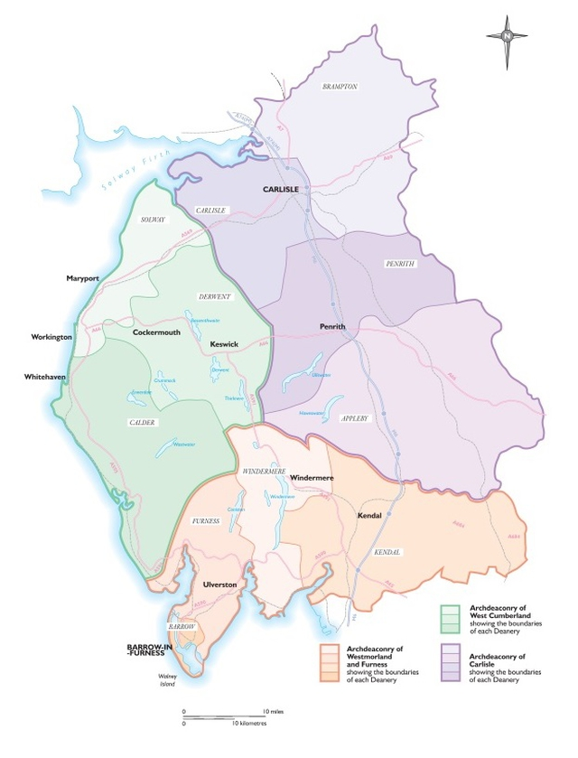
Ministry Experience Scheme: https://www.churchofengland.org/life-events/vocations/ministry-experience-scheme

