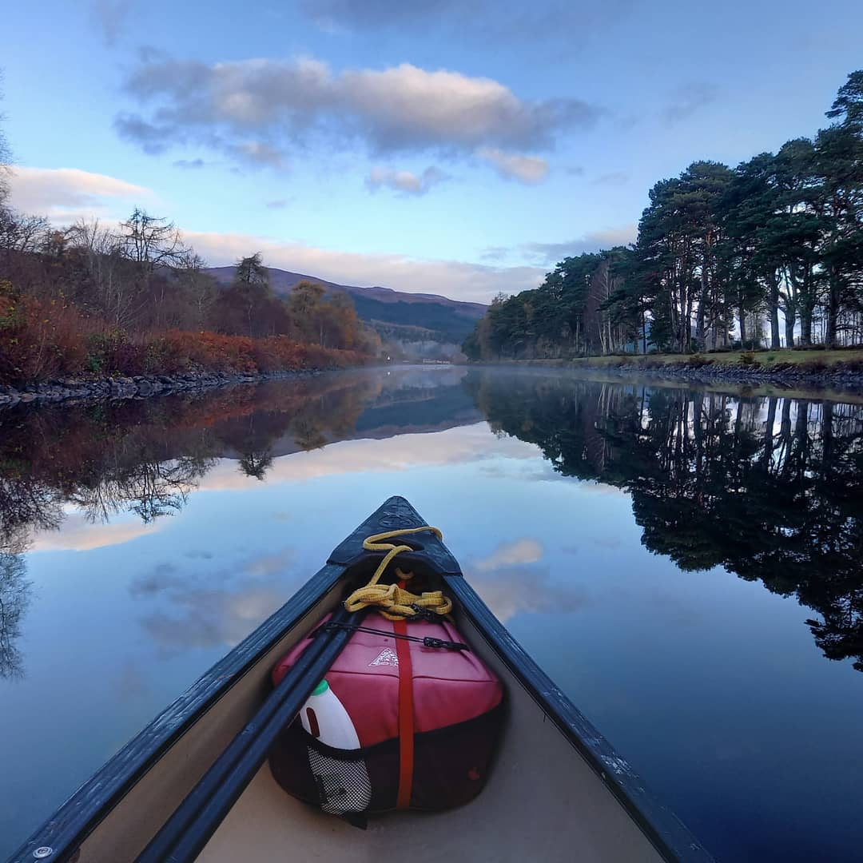
Founded in 1971, Abernethy is a ministry that combines outdoor activity, residential experience and Christian team witness. Adventure is at the heart of Abernethy and we love seeing people gain confidence and grow through being in the outdoors. We run three Centres in Scotland where we warmly welcome thousands of guests each year.
Are you passionate about the outdoors, eager to see lives transformed and able to lead, nurture and grow a team? Would you like to live and work in the heart of the stunning Cairngorms National Park?
We are looking for the right person to lead the ministry at our Nethy Bridge Centre. This will be a challenging, rewarding and exciting role and will be critical in shaping the future of the Abernethy Trust.

The team at Abernethy are all Christians. We are passionate about the outdoors, community, hospitality and witness. We are motivated by our belief in a good and generous God who created an incredible natural world which, through its very existence, shouts His praise. We believe that every person is unique, valuable and deeply loved by the creator God.
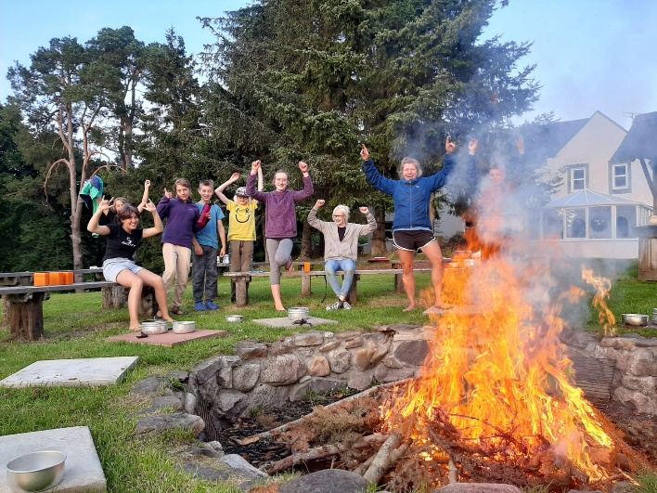
Along with the entire outdoor activity sector, Abernethy experienced a challenging time during the pandemic but guests are beginning to return and we now have a wonderful opportunity to rebuild and refocus. This is an exciting time in Abernethy’s history as we embrace a new season, confident that God has a purpose for us, and with the vision and drive to pioneer new opportunities.
The role of Centre Director is an exciting opportunity for the right candidate to join us as we write the next chapter in the Abernethy story.

OUR PRAYER FOR A CENTRE DIRECTOR
We are seeking God for someone who can take the lead in creating a Centre and building a Christian community that is both welcoming and safe, inspiring and challenging and which enables guests and staff to encounter the transformative power of God’s love.
Our prayer is for someone who can offer the calling, gifts and experience outlined below:
CALLING
- You have a passion to discern and develop the gifts of others and lead them to become committed disciples of Jesus, effective in their work and witness
- You are able to foster a warm, hospitable ambience within the Centre and amongst the staff
- You carry a conviction that faithfulness to the gospel requires us to share the good news in both word and deed
GIFTS & STRENGTHS
- You will be able to oversee Team Leaders, helping them create a harmonious and efficient working environment through collaboration and communication
- You will be able to build a strong Centre team through wise recruitment and excellent people management
- You will recognize the importance of and be able to ensure safe working practices and adherence to legal requirements
- You will be comfortable with taking responsibility for the financial performance of the Centre to ensure resources are used effectively through writing and delivering budgets
- You will play a part in shaping the direction of the Trust by being part of the Abernethy Leadership Team and working closely with and supporting the CEO
EXPERIENCE & QUALITIES
- A mature Christian faith and experience of spiritual leadership
- You understand what is required to inspire and develop a team
- A passion for the outdoors and a desire to use outdoor adventure to share the good news of Jesus
- You will be a role model, a consistent presence for the team and an ambassador for Abernethy
- You have experience of writing and delivering budgets
- You have excellent communication skills
WE WOULD ALSO LOVE YOU TO HAVE
- Experience of change management and rebuilding within an organisation
- Worked in missional teams where you live alongside each other, and therefore understand the dynamics of our residential context
- Excellent Word, Excel, Outlook and IT skills
WHAT CAN WE OFFER YOU?
- A monthly salary (plus allowances as required)
- A house on site
- 30 days paid annual leave (increases with length of service)
- Opportunities for personal development and training
- Use of Centre facilities and equipment
- Favourable rates for family on most Abernethy holidays and camps
- Living as part of a vibrant Christian community in a fabulous location with endless opportunities for outdoor adventure
HOW TO APPLY
Your application should comprise:
- A covering note, of not more than two pages, outlining your motivation and relevant experience for the role
- Christian faith is an Occupational Requirement for this role
- The covering letter should also include the names of three referees. Please note these referees will not be contacted without your prior agreement
- A full CV, including educational and professional qualifications, a full employment history showing positions, responsibilities held and relevant achievements
As part of our commitment to safeguarding, the successful applicant will be required to become a member of the Protection of Vulnerable Groups (Scotland) Scheme and the appointment will be subject to a satisfactory PVG Scheme Disclosure.

Many thanks in advance for your prayerful consideration of this leadership opportunity and for taking an interest in the life and ministry of Abernethy Trust.

Directors: Mrs SE Allen BEd SQH Mr DK Belsham BSc(Eng) CEng FICE A Bevan LLB Hons Dip Th G Brown Dr HT Dougall MRCGP FRCP Rev NM Glover BSc(Hons) BD(Hons) Mrs C Gordon BEd DipCo Alison Smith LLB(Hons) DipLP Dr BM Strickland BDS Mr AS Thomson LLB(Hons) Mrs SE Yarrow BEd
Registered Office Abernethy Trust Ltd Nethy Bridge Inverness-shire PH25 3ED Reg no SC 049387
Abernethy Trust Ltd is a non-profit making Company with Charitable Status (SC 006270) & operates at various locations

