Providing homes and building communities with Christian care and compassion

Recruitment Pack

September 2021

Contents

Welcome from Sharon Lee, Chief Executive 3
Our history 4
Our Values 5
About the Role 6
Management Team 8
Organisation chart 10
Where we operate 12
Role profile 13
Summary of main benefits 19
How to apply 21

Welcome from Sharon Lee, Chief Executive

These are exciting times for Aelwyd Housing as we continue the journey in our full and rich story.

I joined Aelwyd Housing in February 2020 and very quickly saw what an amazing organisation this is. The commitment of our staff to outstanding service for residents is exceptional, and this is reflected in the consistently high satisfaction feedback from the people who live in our homes. Aelwyd has a rich heritage over many decades of being at the heart of communities across South Wales. Our roots are firmly planted in a desire to make a difference, through the homes and services we provide.

Our heritage is important to us, and all our homes are built on former church land that was once used to strengthen community and bring a sense of connection and belonging. Our Christian ethos and our Values underpin all that we do and makes us unique in the Welsh housing sector. This ethos means that we deliver excellent services, with compassion, inclusion, and connection for people of faith or none.

We are ambitious for the future and want to build on our strong heritage and become an organisation that has an even greater impact in Wales.

We are looking for someone exceptional to join us as a Housing Administrator . This is a key role where you will be involved and gain experience in all aspects of our work. Whilst administrative support will be your day-to-day responsibility, our team is small and a willingness to be flexible and adaptable is essential. You will have daily contact with our residents and it’s important that you can relate to them in a compassionate and caring way. If successful you will work closely with all colleagues, including providing administrative support to the Chief Executive. You will be part of taking Aelwyd Housing forward and your thoughts and ideas will be important to shaping how we work.

You will be someone with the drive and passion to deliver excellent services for our residents, you will have a strong team working ethos and the heart for our work. If you think you are the right person to join us then please submit an application. I look forward to hearing from you.

Sharon Lee
Chief Executive

Our History

Aelwyd (which means ‘hearth’ – the heart of a home in the Welsh language) is a Charitable Housing Association, with a Christian ethos.
We were formed in 1991 as a partnership between the Baptist Housing Association (BHA) Presbyterian Church of Wales, and United Reformed Church, Wales Province.
BHA had been founded as the Baptist Men’s Movement Housing Association in 1966 to provide housing for retired Baptist ministers and missionaries, but over the years had expanded to cater for older people in general. In Wales, the first housing scheme was built at Splott in Cardiff in 1978.
The three bodies met together, and discussions took place culminating in the registration of Aelwyd Housing Association in March 1991.
We currently own and manage 256 homes across ten local authorities in South Wales.
Whilst no new building development has been undertaken since 1996 our Board has continued to periodically review and reassess this decision as well as evaluating and pursuing alternative ways and opportunities to grow the business. Our current Business Plan is ambitious in seeking opportunities to grow.
Formerly classed as a De minimis organisation, in October 2017 Aelwyd Housing was brought under the umbrella of full regulation by the Welsh Government. The Association has achieved the highest possible rating (Standard/Standard) each year since. Aelwyd Housing is the only former De minimis housing organisation in Wales to achieve this.
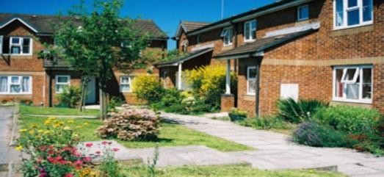
In 2019 we moved from our offices in the centre of Cardiff to Morganstown on the edge of the city, and the beautiful Welsh Valleys. Our location is close to the M4, has parking and excellent transport links.
The Cedars, Llanmartin

Our vision and values

Our vision is our core purpose and the reason why Aelwyd Housing exists.

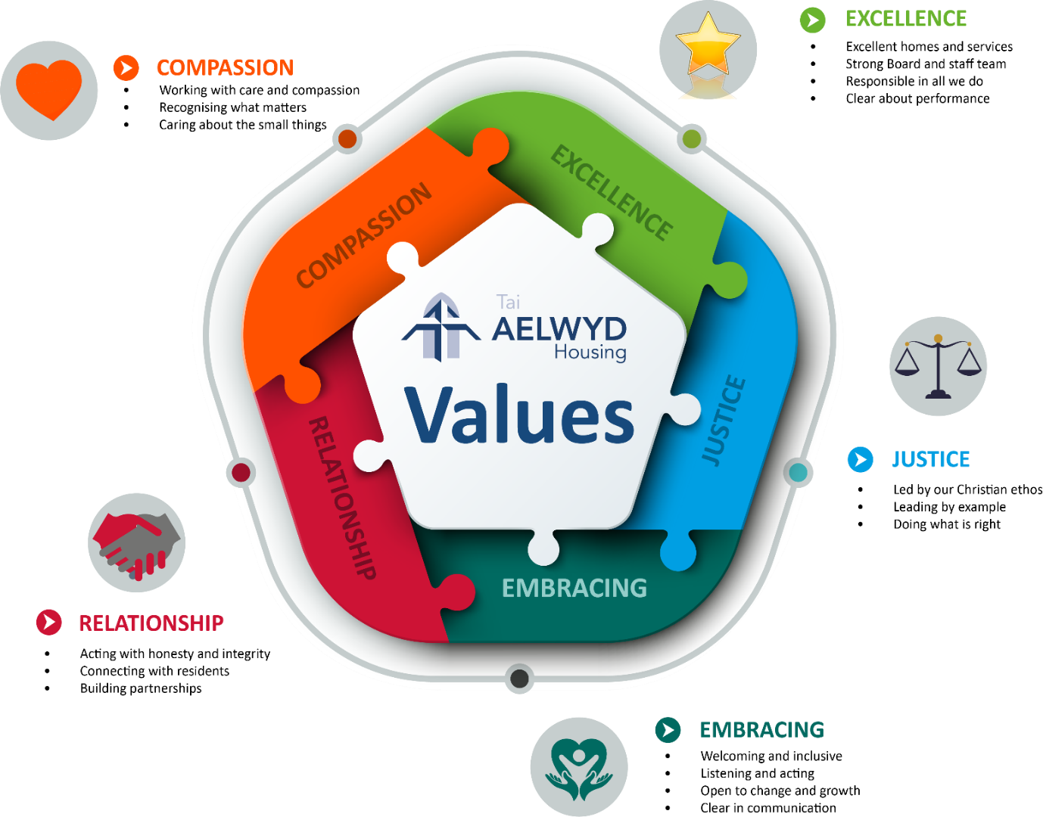
Our Values are at the heart of everything we do and shape our culture. They flow through the way we deliver services, in every interaction with residents, and in how we appreciate and treat our staff.

About the role

This role is a key part of the future success of Aelwyd Housing, and how we support our existing and future residents.

Working closely with the Director of Housing and Communities you will be a key member of the team and will help us deliver our Business Plan objectives. You will provide day-to-day housing and office administrative support and will be a key point of contact for residents.

Our culture is that we know all our residents, and we care about them very much. We live it out each and every day in our actions and the work we do. Our size enables us to spend time with residents, understand what matters to them and then work to deliver it. Our Christian ethos is important to us and gives us a foundation from which we seek to impact communities. We are looking for someone who can empathise with and reflect that ethos.

Working closely within a small team, a broad spectrum of knowledge and a willingness to ‘pitch in’, is essential. The majority of our properties are suitable for people aged over 55 years. Many of our residents are older people, so you will be central to helping deliver services that are important to them.

This role will be office based and will provide essential support to our Community Housing Officer who works across South Wales. You will interact with residents over the phone with the occasional visit to our schemes when required. You will thrive on being organised and good at communicating with others. Attention to detail is very important in this role and enjoying being part of a team is crucial.

This is a new role at Aelwyd Housing, so it’s an exciting opportunity to make it your own. Your voice will matter as our culture is to encourage all staff to bring thoughts and ideas about how we can keep improving.

Management Team

Sharon Lee - Chief Executive

Sharon joined Aelwyd Housing in 2020. She has worked in the housing and homelessness sectors in England and Wales for almost 30 years. Before joining Aelwyd she was the Director of Housing Justice Cymru and was previously Head of Corporate Services at Wales & West Housing. Sharon is a Trustee of her local church and has been involved in community projects for many years.

Sarah Mulcahy - Deputy Chief Executive/ Director of Finance

Sarah has worked at Aelwyd for 26 years starting as Finance Officer and later as Director of Finance. Sarah is a Chartered Management accountant. She wears many hats including Deputy Chief Executive and being responsible for Human Resources. She is an elected member of the Governing Body of the Church in Wales, a Trustee of Monmouth Diocesan Board of Finance and an active member of her local church.
Jeremy Dickson - Director of Property Services

Jeremy joined Aelwyd in 2019 having been a building surveyor for the majority of his working life, initially starting off with central government before spending time with a local authority. He has worked at a number of Welsh HA’s and worked for a large HA on all aspects of the Asset Team’s work.
Gemma Watkins - Director of Housing & Communities

Gemma joined Aelwyd in 2020. She has worked in Housing for almost 20 years, working for a local authority and was Head of Housing & Communities at a community-based housing association. Gemma has served on several boards and has mentored junior housing staff through the CIH. Gemma is a qualified project manager and is passionate about equality and putting residents’ needs at the heart of service design and delivery.

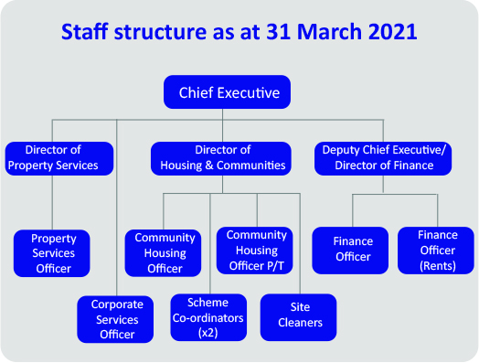
Housing Administrator
Staff Structure

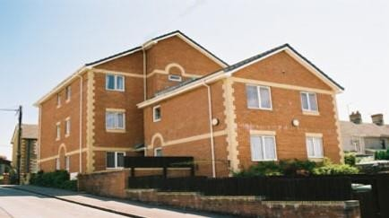
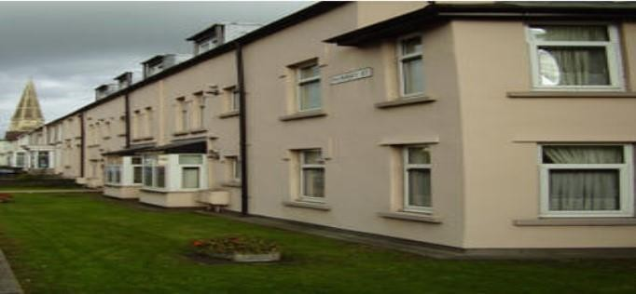
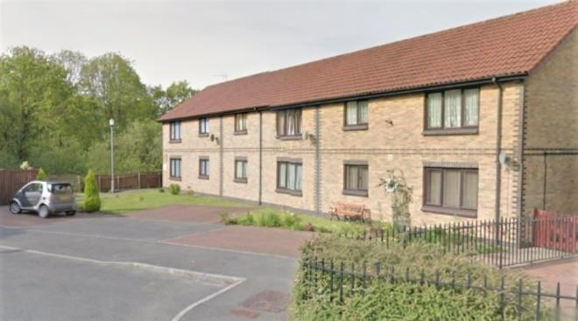
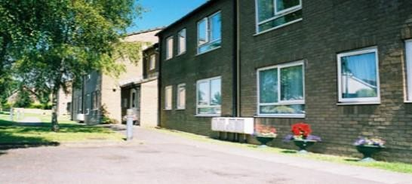
Cwrt Bethel, Pontyclun, RCT
Llys Caeglas, Llanelli
Bethel Place, Llanishen, Cardiff
St David’s Court, Monmouthshire
Where we operate

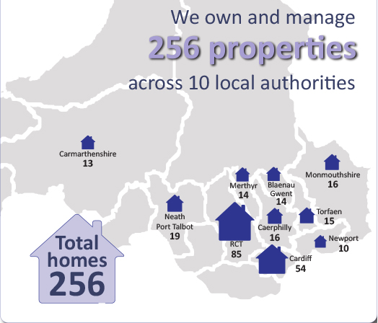

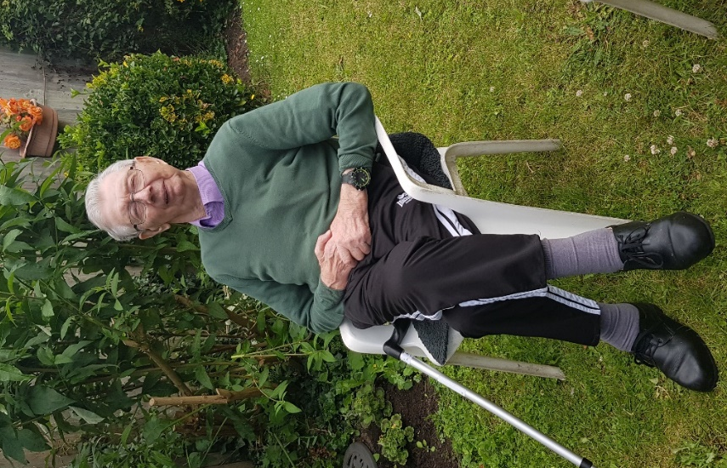
Housing Administrator
Role Profile

Responsible to: DIRECTOR OF HOUSING & COMMUNITIES

Responsible for: N/A

Job Purpose
- To be part of the team responsible for the delivery of housing management services to residents
- To be the first point of contact for resident enquiries received via telephone, in person, online or in writing.
- To enable the delivery of services to residents by providing administrative support to colleagues. To contribute to the development of projects that put residents at the heart of service design and delivery
- To provide admin support to the Chief Executive and Directors team as required
- To work in line with our Christian ethos and values, in contributing to the provision of high quality services with care and compassion

Accountabilities
  - Providing office based day to day admin support, primarily related to services to residents
  - Being a point of contact when residents and other stakeholders contact Aelwyd Housing
  - Keeping accurate records on a variety of systems and platforms.
  - To assist in the production of the quarterly resident newsletter and other external publications
  - Working closely with the Chief Executive and other Directors to provide admin support in producing reports for the Board and for Welsh Government.
  - To be friendly, people focused, values driven and have the ability to connect with colleagues and residents.
  - To be highly organised with an ability to focus on attention to detail.
  - To be a good team member and work with colleagues to ensure the whole organisation is able to deliver on its strategic priorities.
  - To set an example by having passion for our work, empathy and understanding, and compassion for people in housing need and those who live in our homes.
  - The confidence and ability to think creatively and share ideas to help us improve.
  - To be a role model and ambassador for Aelwyd Housing, both within the organisation and externally and align with our ethos at all times.
  - To strive to improve our services and develop services that matter to residents and their community.
  - To have due regard for the environmental impact of carrying out your duties and where possible adapt your practices accordingly.
  - To comply with all the Association’s policies and procedures including those relating to Health and Safety and Equality.
  - To carry out any other duties commensurate with the post as reasonably requested by the Director or Chief Executive.

General

The above responsibilities should be read in conjunction with all express contractual terms
relevant to your employment and any other non-contractual Policies and Procedures published by Aelwyd Housing, which are amended from time to time.

In addition to the specified Job Purpose and Accountabilities all staff are expected to:-

Equality
Proactively promote the principles and practices of equality of opportunity, to ensure its effective implementation within their own work and the work of team members, as appropriate and to abide by and support the Aelwyd Housing’s Equal Opportunities Policy as an integral part of all duties

Health and Safety
Understand their personal responsibilities for ensuring the highest standard of Health and Safety towards themselves and others (e.g. colleagues, team members, residents, the public, etc.). Understand the Aelwyd Housing Health and Safety Policy, including details of relevant responsibilities for employees, managers and senior staff members as well as the consequences for failing to follow them.

Confidentiality
Have a duty of confidentiality to residents, staff/colleagues, and any other persons or organisations data/information that may be used or held by Aelwyd Housing. All data/information should be treated as confidential and should only be collected and/or disclosed on a need to know basis and where a legal basis has been satisfied in the relevant legislation
Under no circumstances should any personal data/information or sensitive personal data/information or business sensitive data/information be divulged or passed on to any persons or organisations that are not permitted to receive such data

Data Protection
In line with legislation, and organisational policy, all personal data/information will be processed in line with the Data Protection Act 2018. This includes how staff collect, use, retain, share and destroy personal data/information
Value for Money and Financial Regulations
Understand that when involved in making decisions to procure goods or services, staff are responsible for doing the right thing to ensure that value for money is achieved. This may involve conversations with specialist or more senior members of staff before any commitment to purchase is made, seeking approval in accordance with the Delegated Authority List and the Financial Regulations. All purchasing decisions and any costs incurred on behalf of Aelwyd Housing must be reasonable, made in a responsible manner, supported by a genuine business need and represent good value, in accordance with Aelwyd Housing policy and procedure
Learning and development
Attend and engage in all training identified as necessary to the role. This may involve achieving competency in specific areas to ensure legislative compliance and participating in developmental training to promote organisational culture. Staff will also be required to participate fully in the Aelwyd Housing performance development process and personally commit to identifying, achieving and maintaining the skills and qualities required to fulfil their role and maximise their potential

Person Specification

 | Essential | Desirable:
Education | Educated to a good standard e.g 5 x GCSE’s A*-C including English and Maths, or equivalent.  Excellent literacy and numeracy skills
Experience | - Experience of working in a customer service or public facing role  - Experience of working in an office environment  - Experience of providing administrative support | - Experience of working in the social housing or related sector  - Experience of dealing with residents or clients, some of whom may require a wide range of support  - Experience of working with communities and churches
Knowledge | - Up to date knowledge and competent user of Microsoft Office packages such as Word, Excel, PowerPoint and Outlook.  - Knowledge and Competent user of online meeting platforms such as Zoom, Microsoft Teams, GoToMeeting | - An awareness of the role of social landlords  - An awareness of the issues that affect older people  - Health & Safety and Equality awareness
Skills | - A commitment to customer care and delivering excellent customer service  - Excellent communication skills, in writing, in person and over the telephone.  - A flexible and cooperative approach understanding the wider impact of work on other members of staff.  - Ability to use own initiative.  - Methodical approach to work, attentive to detail, able to plan, prioritise workload, meet deadlines and work without close supervision.  - Excellent organisational skills and good at problem solving  - A confident and competent decision maker, with the ability to respond to day to day enquiries  - Ability to work well as part of a team, bringing a positive attitude and the ability to work with staff from across the whole organisation. | - Ability to speak Welsh or another community language  - Transferable skills gained through knowledge of other sectors  - Ability to undertake occasional travel throughout South Wales, with access to own vehicle,  - Ability to work occasionally outside of office hours
Personal Qualities | - Self-aware and displays respect and empathy for residents and colleagues  - A commitment to Aelwyd’s Christian ethos and values.  - Positive attitude with the confidence to constructively challenge the status quo

Summary of main benefits

Working for Aelwyd Housing gives you access to a great range of benefits such as, a generous annual leave entitlement, competitive salaries and a range of health and wellbeing benefits:
Competitive salary
We offer a competitive salary with an annual review.
Annual leave
You are entitled to 25 days leave per year pro rata, increasing by one for every year of service up to a maximum of 30, plus the designated statutory bank holidays
Pension
We know that financial security has a positive effect on wellbeing whether you are close to retirement or not. We offer a Defined Contribution (DC) Scheme.
Employee wellbeing
Our staff are important to us. That’s why we’re committed to offering the widest possible range of working arrangements to support and promote your wellbeing, and work- life balance.
Supporting through illness
If the unfortunate happens and you are unable to work through sickness, illness or injury, Aelwyd Housing supports you with an occupational sick leave scheme and appropriate role adjustments.

Learning and development
We value our staff highly and want to invest in providing the right support and skills to really make a difference in the services we provide. We regard the development of our staff as a key responsibility of everyone’s role. All staff must make a personal commitment and investment of time to access learning and development opportunities that will enhance personal growth and develop skills and behaviours.

Advert

Housing Administrator

Location: Cardiff Office based role

Hours: 35 hours full time

Contract type: Permanent

Salary: £21,000

If you are passionate about addressing housing need, and believe that everyone should live in a well maintained home they can afford, with a landlord who provides excellent housing services; we want to hear from you. This is a great opportunity to join Aelwyd Housing, a values-based organisation which strives to live out its Christian ethos each and every day through our work with people of faith and none.
The opportunity
This is an opportunity to join us at an exciting time for the organisation, and be part of our team working across South Wales. You’ll be based at our office in Cardiff, with the flexibility to occasionally work from home. Aelwyd Housing has been through a period of transition over recent years, and we are stronger than ever. This is an opportunity to be part of our future and help us move into it.

The role
Working with the Director of Housing and Communities and our Communities Housing Officer, within our Housing Management Team, this is an opportunity to deliver services that matter to our residents and to engage and connect with the communities within which we work to build resilience and capacity.

We work in ten local authorities across South Wales, and you will help ensure there is a consistent approach to excellent services for everyone who lives in one of our homes. The role also requires the ability and vision to challenge the norm, and contribute to new projects that matter to our residents and the community. We need someone who enjoys being part of a team, and thrives on being highly organised with giving attention to detail.

The organisation
We are a charitable housing association that owns and manages 256 homes, predominantly for people aged over 55, throughout South Wales. With a proven track record of providing high quality accommodation and services, Aelwyd Housing receives consistently high levels of resident satisfaction, and is able to provide a consistency and continuity of service to a very high standard.
The candidate
You will bring personality, experience, and knowledge of what it takes to deliver excellent customer service. You will be committed to ensuring residents are at the heart of all we do, and you will care passionately about making a difference. You will be able to demonstrate an empathy with our Christian ethos and a determination to see it continue to be our bedrock.

How to apply

Thank you for your interest in this position. This information will help you complete your application.

Please visit our website or contact Joan Mumford joanm@aelwyd.co.uk to ask for an application form and ensure that you submit it before the closing date. We do not accept CVs.

If you cannot attend the advertised assessment date(s) please indicate this in the appropriate place on the application form.

The equal opportunities information requested is for monitoring purposes only, in line with our commitment to equality and diversity, and will not affect the outcome of your application.

It is your responsibility to ensure that we have received your application. If you don’t receive confirmation of receipt of your application from us within 24 hours of sending, please email Sarah Mulcahy as above to make sure it has arrived.

Key dates

Closing date for applications: 9am on Friday 08th October 2021

Email address for sending applications: joanm@aelwyd.co.uk

Address to post application:

Aelwyd Housing Association
9 Ty Nant Court Morganstown Cardiff
CF15 8LW

Formal interviews: Tuesday 19th October 2021.

The Interview process may be conducted virtually via Zoom due to Covid19 restrictions.

If sending an application in the post, please mark correspondence
Private & Confidential FAO the Director of Finance

If you would like to arrange an informal chat about the role, please contact Gemma Watkins, Director of Housing and Communities via email gemmaw@alewyd.co.uk

For additional information about Aelwyd Housing please visit www.aelwyd.co.uk

Head Office

9 Ty Nant Court Morganstown Cardiff
CF15 8LW

Telephone:
029 2048 1203
Website:
www.aelwyd.co.uk

