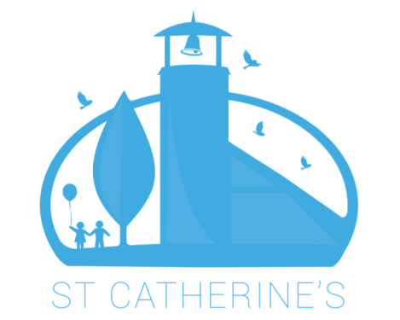

JOB APPLICATION FORM
Thank you for your interest in working for The CROSS Project and St Catherine’s Church. Please complete this application form and return it to the following email address by the closing date office@crossproject.co.uk.

Post Applied For:

Surname
First name(s)
Current Address including postcode.

Date of Birth
Telephone
Email address
N. I. Number

How did you hear of this vacancy?

Do you have access to a vehicle and a full driving licence?

If you are currently employed, what notice period would you be required to give?

Relevant qualifications and training

SCHOOLS / COLLEGES / TRAINING / UNIVERSITIES ATTENDED | DATES ATTENDED | SKILLS / KNOWLEDGE OR QUALIFICATIONS GAINED

(Please continue on separate sheet if necessary)
Employment

Please also include and identify any appropriate volunteer experience. Please start with the most recent and work backwards.
EMPLOYER/ORGANISATION  Name, address, phone, email | JOB TITLE & EXPERIENCE / SKILLS GAINED  Please also give reason for leaving. | DATES

(Please continue on separate sheet if necessary)

APPLICATION STATEMENT

Please give a statement in support of your application. Use this section of the application form to demonstrate how you meet the requirements of the Person Specification and to explain why you are applying for the job.

APPLICATION STATEMENT CONTINUED

Please use this space to continue your application statement.
(Please continue on separate sheet if necessary)

REFERENCES

Please give details of three people whom we may contact for references. References will be taken up if you are short-listed. At least one of these referees should have knowledge of your professional practice and one should be from your present, or most recent employer, and the one of the others should be able to support the information you give regarding your faith. If you have not previously been employed, then Head Teachers / College Lecturers etc. are acceptable as referees.
NAME | HOW THEY KNOW YOU | ADDRESS, TELEPHONE NUMBER & EMAIL | CONTACT BEFORE INTERVIEW  (Yes or No)

DECLARATION: I certify that all details given are correct and understand that should any false statement(s) or omission(s) be made on this form The CROSS Project and St Catherine’s Church reserves the right of dismissal. I understand that employment with The CROSS Project and St Catherine’s is subject to the receipt of satisfactory references and formal clearance of any criminal background. I can also confirm I am eligible to work in the UK.

Signature…………………………………………………………………… Date…………………………

(Should you attach any sheets, please can you ensure that there are clearly identifiable as yours).

