Thank you for your interest in this exciting position of Financial Controller at AoG.

We hope this pack will give you everything you need to inform you and help you make a decision whether this is the right role (and organisation) for you.

In this application pack, you will find more info on the:

- AoG Vision
- Job Description
- Person Specification
- Summary of the main terms & conditions for the role
- How to apply

AoG Incorporated (AoG) is a nationally recognised Pentecostal denomination that has been serving the people of Great Britain since 1924. There are around 500 churches and 900 ministers engaged with AoG. At the core of the AoG is a passionate desire to see God’s Kingdom grow through the local church.

We are at an exciting time in our movement as our Leadership team is shaping our vision for the future and we are looking for people to actively support us in achieving this vision.

We hope this pack gives you what you need to decide on your next step, if however you would like an informal discussion about any aspects of the role or if you have any questions about this pack, please contact hr@aog.org.uk.

We look forward to hearing from you!

AoG Vision

Our National Leader, Ps Glyn Barrett set out his vision for AoG as a movement in 2019. He looked at where we have been as a movement, where we are now and where God is taking us.

Below is a brief summary of the vision, along with a visual for the Future:

PAST
- Re-discovering our Pentecostal roots
- An honour culture for our older ministers

PRESENT
- Church growth over the decades
- Instigation of a Health Check
- Re-evaluate where we are

FUTURE
Focus on:
- Leadership Development
- Church health
- Mission

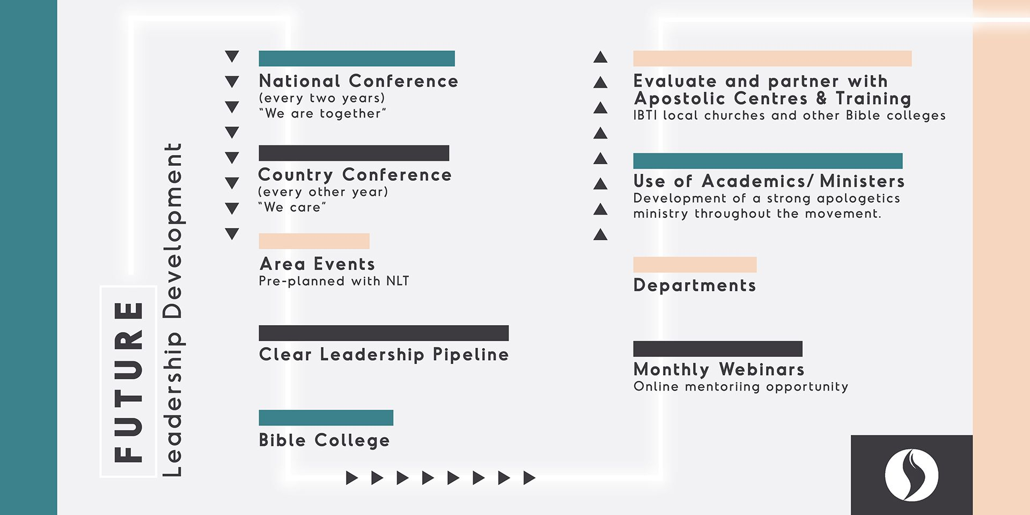
Click here to read more about what we believe as a movement.
Job Description

FINANCIAL CONTROLLER

Purpose
This role will be responsible for the day-to-day running of the Finance Department. Reporting to the Head of Finance this role will ensure that systems and processes are managed efficiently, month end accounts are prepared on a timely basis and departmental budgets are managed effectively. This role will also oversee two Finance team members.

Key Tasks and Responsibilities
- Ownership of day-to-day activities within the Finance Department.
- Completion of monthly balance sheet reconciliations and management accounts.
- Preparation of draft financial reports for Board.
- Data analysis to provide meaningful reports and recommendations.
- Ensure Financial Systems and Processes are adhered to.
- Point of contact for liaising with external Auditors.
- Oversee departmental budgets to ensure budget holders are running to budget.
- Preparation of monthly payroll for payroll agency.
- Manage credit control for outstanding debt.
- Work alongside the HR department to ensure staff salaries and pensions are managed effectively.
- Preparation of monthly bank payments for authorisation by the Head of Finance.
- Manage and train two junior members of the Finance Team.
- Commitment to maintain the highest standards of excellence and integrity in order to serve the internal and external functions of AoG Inc. well.
- Any other duties as required by the Head of Finance.
Please note: this role is based in Manchester and may involve some UK wide travel.
Financial Authorities
No direct budgetary responsibility however the role holder will be responsible for the:
● Preparation of monthly bank payments.
● Preparation of monthly payroll reports.
● Oversight of monthly departmental budget holders.
Reporting Line
Report to: Head of Finance

Person Specification

FINANCIAL CONTROLLER

 | ESSENTIAL | DESIRABLE
Qualifications | Qualified Accountant either by qualifications or experience | ACA / ACCA qualification
Skills, Abilities, Knowledge | Excellent attention to detail  Comprehensive understanding of accounting systems and processes  Excellent organisational, planning and time management skills  Strong communication skills  Inspirational manager, ability to lead a team effectively  Advanced Excel skills | Experience of SAGE
Experience relevant to the role | Experience in preparing monthly balance sheet reconciliations  Able to prepare management accounts to review stage  At least 5 years’ experience working in finance  Experience in managing staff  Experienced in delivering high quality reports to a fixed deadline | Experience in Charity finance  Understanding of restricted funds
Personal Qualities | Takes pride in delivering work to an excellent standard  Commitment to follow a task through to be completion  Initiative to identify and bring recommendations for improvement  Takes ownership of responsibilities. Able to work effectively without being closely managed  Solution focused; finds a way to get things done  Non-confrontational management style. Ability to train and nurture others  Open and responsive to feedback  Demonstrate a professional approach in everything you do
Misc | Ability to be flexible in working hours
Commitment to Vision, Values and Beliefs of AoG | AoG Inc is a Christian organisation with a mission to Serve and Empower its churches and ministers. Despite there not being an occupational requirement to be a Christian the candidate must respect and reflect the organisation's vision and beliefs and act in the utmost integrity and sincerity at all times.
The role holder will need to provide two satisfactory references and the relevant Right to Work in the UK

Summary of the Main Terms and Conditions for the Role

Job title | Financial Controller
Duration of role | Permanent
Probationary Period | Three months
Ideal start date | July 2021
Location | Manchester AoG Offices
Hours & days of work (per week) | Full time (35 hours per week over 5 days)
Salary (per annum) | C. £30,000 per year, depending on experience
Annual leave entitlement | Holiday year: 1st July - 30th June  33 days per year (inclusive of Bank Holidays) for full-time employees, this is pro-rated for part-time employees
Pension | After 3 months probationary period
Required checks (e.g. DBS, References, Right to Work) | 2 references  Right to work in the UK

How to Apply

Please send a completed AoG application form to:

hr@aog.org.uk

Closing date for applications: Friday 11th June 2021

Anticipated interview date(s): Circa end June 2021

