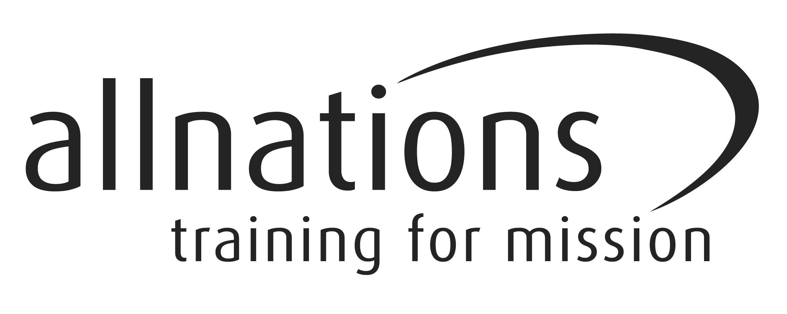

ALL NATIONS CHRISTIAN COLLEGE

EQUALITY AND DIVERSITY MONITORING FORM FOR APPLICANTS

All Nations Christian college wants to meet the aims and commitments set out in its equal opportunities policy. This includes not discriminating under the Equality Act 2010, and building an accurate picture of the make-up of the workforce in encouraging equality and diversity.

The College needs your help and co-operation to enable it to do this, but filling in this form is voluntary.

The information you provide will stay confidential, and be stored securely and limited to only some staff in the College’s Human Resources section.

Gender Male Female Prefer not to say

Are you married or in a civil partnership? Yes No Prefer not to say

Age 16-24 25-29 30-34 35-39 40-44 45-49 50-54
55-59 60-64 65+ Prefer not to say

What is your ethnicity?

Ethnic origin is not about nationality, place of birth or citizenship. It is about the group to which you perceive you belong. Please tick the appropriate box.

White
English Welsh Scottish Northern Irish Irish
British Gypsy or Irish Traveller Prefer not to say
Any other white background, please write in:

Mixed/multiple ethnic groups
White and Black Caribbean White and Black African White and Asian
Prefer not to say Any other mixed background, please write in:

Asian/Asian British
Indian Pakistani Bangladeshi Chinese Prefer not to say
Any other Asian background, please write in:

Black/ African/ Caribbean/ Black British
African Caribbean Prefer not to say
Any other Black/African/Caribbean background, please write in:

Other ethnic group
Arab Prefer not to say Any other ethnic group, please write in:
Do you consider yourself to have a disability or health condition?
Yes No Prefer not to say

What is the effect or impact of your disability or health condition on your ability to give your best at work? Please write in here:

The information in this form is for monitoring purposes only. If you believe you need a ‘reasonable adjustment’, then please discuss this with the College Administrator.

What is your sexual orientation?
Heterosexual Gay woman/lesbian Gay man Bisexual
Prefer not to say If other, please write in:

What is your religion or belief?
No religion or belief Buddhist Christian Hindu Jewish
Muslim Sikh Prefer not to say If other religion or belief, please write in:

What is your current working pattern?
Full-time Part-time Prefer not to say

What is your flexible working arrangement?
None Flexi-time Staggered hours Term-time hours
Annualised hours Job-share Flexible shifts Compressed hours
Homeworking Prefer not to say If other, please write in:

Do you have caring responsibilities? If yes, please tick all that apply
None Primary carer of a child/children (under 18)
Primary carer of disabled child/children
Primary carer of disabled adult (18 and over) Primary carer of older person
Secondary carer (another person carries out the main caring role)
Prefer not to say

Thank you for completing this form.

