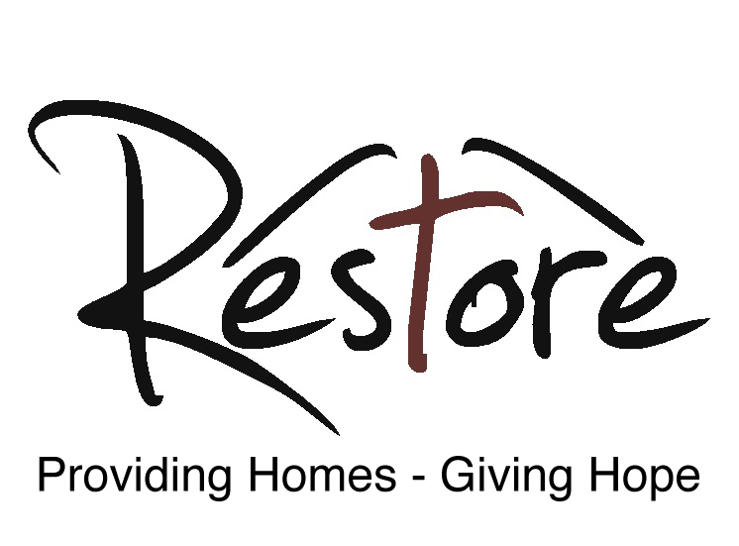

Community Fundraiser and Marketing Officer

www.restoreyork.co.uk
Our vision:
Our vision is for a York where everybody has a home, where those who have been homeless are rebuilding their lives, and where the city works together to beat the underlying causes of homelessness.

Our mission:
We provide a loving space where lives can be restored. Everyone deserves a place they can call home, but society’s injustices can put unbearable financial and personal pressure on some people. Where that gets too much, and people have become homeless, Restore relieves the pressure. We provide safe and stable homes, one-to-one mentoring, love, mental health support, social activities and the offer of Christian support and prayer. Through our work, we also show that by easing the pressure that leads to homelessness, we can create a better society for all of us, freeing more people to achieve their full potential.

Restore was registered as a charity in 2010 and opened its first house in 2011. Since then we have provided accommodation and support for approaching 200 people from York who would otherwise be homeless. More than that, we have seen many lives transformed for a better future. As our tenth anniversary approaches, we want to share our story as widely as possible.
As part of this mission, Restore seeks to employ a part-time Community Fundraiser and Marketing Officer for 14 hours a week (0.4 full time equivalent) to join our existing team of staff. Flexible working arrangements are available. The salary for the role of Communications and Marketing Officer is £19,000 - £22,550 pro rata per annum.
If you wish to be considered for this position, please send a copy of your CV and a brief supporting statement on how your experience and expertise meets the requirements for this role to:

Ed Hambleton
Restore (York) Ltd
The Flat
Gateway Centre
Front Street
Acomb
York
YO24 3BZ
ed.hambleton@restoreyork.co.uk

The closing date for applications: 9 April 2020. Interviews will be held during the week commencing Monday 20 April 2020.

Key areas of responsibility:
- Developing and implementing a fundraising and marketing strategy for Restore’s ten-year anniversary celebrations.
- Promoting, publicising and increasing the profile of our work to stakeholders, the general public and other potential donors
- Organise and run fundraising and profile-raising events
- Ensure that the work of Restore is regularly reported in the press, online media and radio.
- Production of the design and content of the marketing material, such as the newsletters, website and social media channels
- Developing and implementing a strategy for increasing the level of regular and one-off gifts
- Motivating and facilitating supporters to maximise the funds they raise
- Developing new fundraising initiatives

Person Specification
It is essential that the candidate has experience and expertise in charity fundraising, communications and marketing. It is also essential that the candidate has strong admin skills as well as being conversant with IT programmes such as Microsoft Office, Email, Webforms, etc.
Essential
- Experience working in fundraising and marketing
- Ability to show compassion to people in need
- Ability to understand the needs of the client group
- Ability to manage your time and workload independently and effectively
- Excellent written and verbal communications skills
- Proven ability to produce high quality promotional material
- Sympathetic to the Christian worldview and faith
- Experience in running fundraising events
- Experience in writing press releases
- Experience in running social media campaigns
Desirable
- Experience in managing websites
Training
It is recognised that most applicants will not have extensive knowledge and experience of all aspects of the role. Restore will provide access to training which it deems is required in order to equip the successful candidate with the skills to perform the role well.
Restore will provide new entrants with a Staff Handbook which will give a comprehensive overview of the role as well as information about other services locally. An induction period with the CEO and Senior Housing Manager will be provided which will include shadowing of other members of staff.
Due to the strong Christian ethos which underpins the values of Restore (see below) and its service delivery there is a genuine occupational requirement for the postholder to be a practising Christian.
Our values:
“…This is the kind of fasting I want: Free those who are imprisoned; lighten the burden of those who work for you. Let the oppressed go free, and remove the chains that bind people. Share your food with the hungry, and give shelter to the homeless. Give clothes to those who need them, and do not hide from relatives who need your help…. Some of you will rebuild the deserted ruins of your cities. Then you will be known as a rebuilder of walls and a restorer of homes.”

Restore is an anti-poverty charity that works with people of any faith or none. We are grounded in Christianity, particularly in scriptural calls to engage in social action and to pursue justice. Restore’s founders were inspired in particular by Isaiah 58, a rallying call to take action to help those in need and to oppose injustice.

Suppose you see a brother or sister who has no food or clothing, and you say. “Goodbye and have a good day; stay warm and eat well” – but then you don’t give that person any food or clothing. What good does that do?”

We work with other statutory and charitable organisations in and around York, to provide homes for people who would otherwise be homeless, and to identify and address the underlying causes of homelessness. We love our tenants and we stand shoulder to shoulder with them as they rebuild their lives.

“Speak up for those who cannot speak for themselves, ensure justice for those being crushed. Yes, speak up for the poor and helpless, and see that they get justice.”

We are loving. We love our tenants and want what is best for them. Their welfare is paramount to us. We comfort them in hard times and rejoice with them in their progress.

We are Christian. Our trustees are Christian and much of our support comes through local churches. We pray for our tenants and for wisdom in our decisions.

We are enabling. We are a stepping stone for people on their way to a better life, supporting them as they build a new home and new hopes.

We are vocal. We speak up for our tenants and for people who are homeless. It is simply not right that society tolerates homelessness and denies justice and dignity to our fellow citizens. We speak truth to power and call out injustice when we encounter it.

We are confident. We know homelessness can be ended. We believe York can help lead the way.

