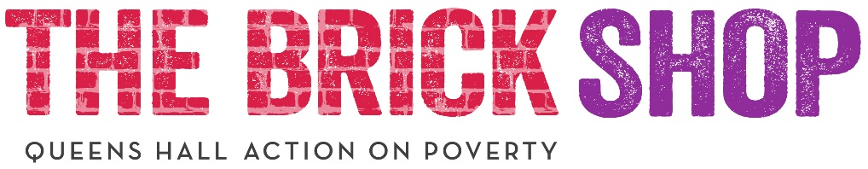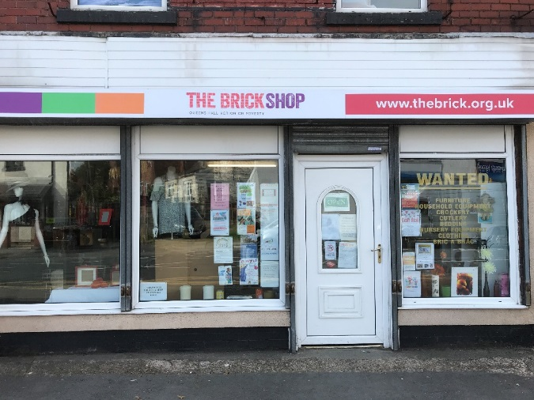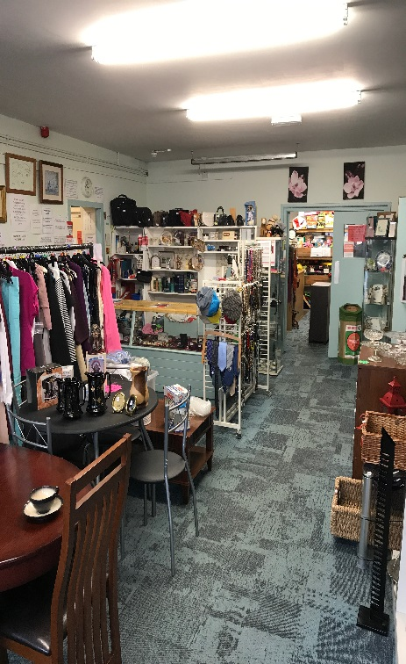

The brick shop is a charity shop selling donated goods often to people on low incomes. We provide clothing free of charge to people referred to us by Wigan council. The shop is one of the main hubs within its local community reducing isolation and supporting people of the borough.

During 2018, the shop continued with its welfare referrals for clothes, bedding, & furniture, with referrals totalling 130 up to the 30th of September 2018.

Finally, all this is, and continues to be made possible due to the generosity of the general public donating. In addition to the tireless efforts of staff & our amazingly wonderful  volunteers, who give their free time to make this make this wonderful project what it is today.

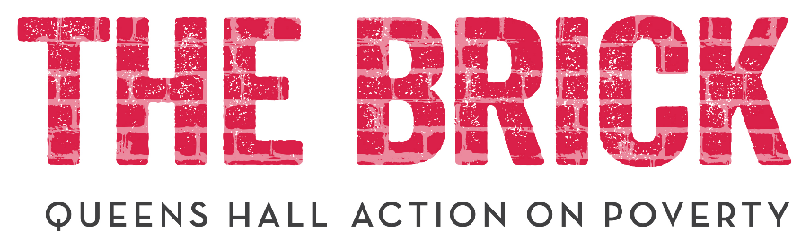

**Annual Assembly**

**1st April 2017-31st March 2018**

**Vision statement**

To eradicate poverty and homelessness in our community

**Mission statement**

Operating with Christian values and working with people of all faiths or no faith, we will help empower people through positive engagement to;

- build independent lifestyles,

- live in good housing,

- be ready to take up work opportunities, and

- gain financial independence

**Values statement**

• We undertake social action which nurtures the fullness of life for service users, staff and volunteers

• We will innovate and take managed risks to support people make a real difference to their lives

• We offer an inclusive, non-judgemental service where discrimination in any form will not be tolerated.

• We employ a professional staff and volunteer team dedicated to the potential of our service users

• We develop relationships and partnership which are central to our work

• We are a caring, compassionate organisation that values our staff, volunteers, partners and service users.

• We will offer a local and user led service.

• We work in a way that is sustainable to the physical environment

The shop has seen a steady growth in sales from 1st of April 2017 to 31st of March 2018, with sales totalling £61-953-95 and is on track to do even better this financial year. We continues to offer low priced clothes, bedding , furniture & household items to people within the borough & beyond & retains its community hub ethos.

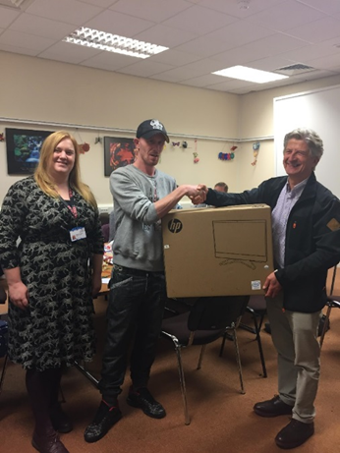

Chair of Trustees

John Wesley, the founder of the Methodist Church, said:

‘Do all the good you can, By all the means you can, In all the ways you can, In all the places you can, At all the times you can, To all the people you can, As long as ever you can.’

The Brick formerly started life on 1st July 2008. So, we are 10 years old! (Note the idea of buying and refurbishing The Bricklayers Arms in Hallgate came 4 years earlier.) What a journey it has been. Throughout, our hallmark has been compassion and doing good to those in need.

Here are some thoughts/memories on last year.

* Birthday Bash. What a great time we had at The Brickworks: music, food, loads of people. What a buzz!

* Kathleen Pitt. Kathy, who led us admirably as CEO, retired on 31 December 2017. She greatly helped to shape us for future growth.

* Nick Brooks. Nick became our Business and Finance Director to great effect. He showed us what an important role business can play in the development of The Brick. Since he returned to being an advisor, Ged Bretherton has taken on the position,

* Wigan Athletic. Our partnership with ‘The Latics’ has been ever so fruitful in that it was the basis for a record year of fundraising. What is really exciting is that we have been chosen, out of a field of 30 charities, to be their charity of the year for an unprecedented second year. This is wonderful news.

The team of Activity co –coordinators schedule a week of regular activities for individuals to choose to constructively spend their time. As well as working in an asset, strength based approach and sitting down with each individual and giving them the opportunity to tell us what they would like to get involved with to allow us to construct together a support plan around this individual and their needs, both in the moment, and long term to help assist in sustaining their move on tenancy.

Whilst it remains early days, so far to date we have had 93 different individuals accessing the hub.

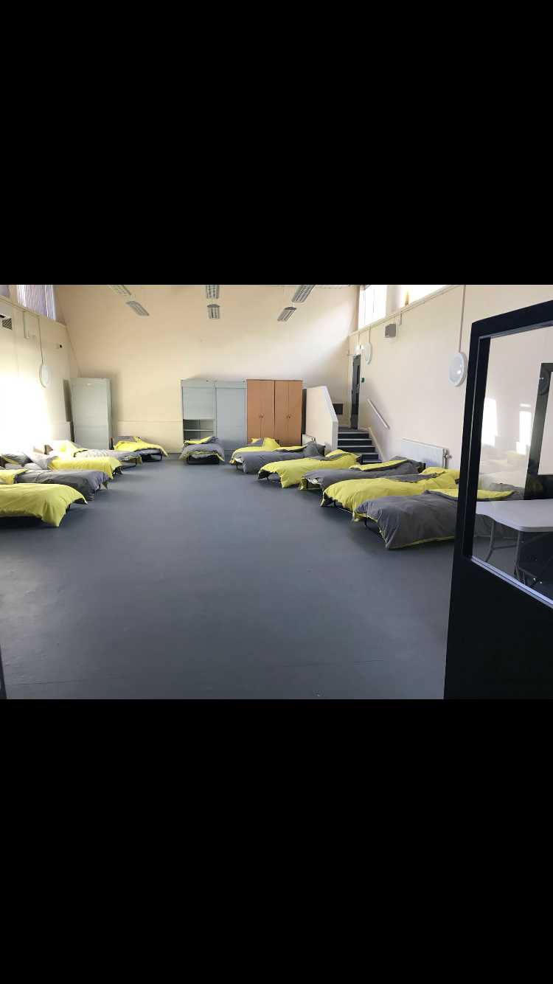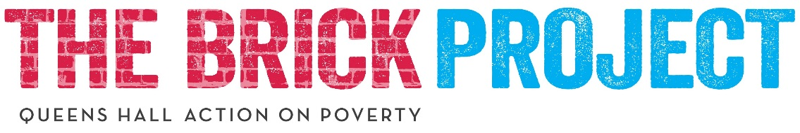

Individuals referred into the emergency access accommodation are given the provision of a safe, warm welcoming environment where they can work in conjunction with services such as The Brick’s Independent Living mentors, Asset coaches, Wigan councils housing team, Addaction and Mental Health.

After much anticipation the new 24/7 Leigh hub was opened on 4th August 2018.

The outset of the provision was to combine services within borough under one roof providing a holistic approach to homelessness, to support individuals going through a transitional period in their lives into a sustainable future.

**Trustees**



**Operations Director Update**

I think I speak for all staff and volunteers when I say, “It’s been a very busy year!” But once again, I am always overwhelmed by the dedication from each staff member and volunteer who give selflessly day after day. Because of this dedication in which staff and volunteers truly believe in what we are trying to achieve has meant that we have been successful in obtaining the largest Contract for our services we have ever had. We continue to support more and more people transitioning through homelessness, crisis or both and the level of complexities that people are transitioning through continue to increase.



Queen’s Hall Methodist Church must be commended on their dedication to those transitioning through homelessness as they opened their doors for 5 months, providing a temporary shelter until the Leigh Hub was ready in July. The Leigh Hub is now providing 15 bed spaces to preventing and relieving rough sleeping. The Hub has been a real challenge for the Charity as we stepped into an area outside our comfort zone, providing 7 days a week 24 hours a day support, but once again rose to the challenge and continue to learn and improve the work we carry out. This service will grow again once the Wigan Hub is ready to open in early 2019 and we are proud to also be providing this service.

Nick Brookes gave us 6 months of his time, to truly catapult us for readiness to grow and Ged now joins us to carry on this forward momentum and engage businesses to help us become more sustainable.

Once again, I wish I could truly say in words how much I admire, respect and appreciate every staff member and volunteer who makes this happen every single day. Thank you!

This year for the first time ever, we secured a 6-bed unit providing an exceptional standard of living accommodation, targeting not only rough sleeping, but personal development through the Brick Works, in which people learn skills, socialise and become ever more independent in their communities. In the next 12 months we would like to replicate this model in Wigan and we are already speaking to landlords willing to step up to the mark and make available accommodation which people can be proud to live in.



I personally feel that this year has been the most successful I have witnessed. The Charity has achieved so much in the space of 12 months and I genuinely feel we are at a point where we can no longer call ourselves a small charity.

The Brick Project completely changed its way of working and focused its efforts towards an asset based approach, taking inspiration from the Mayday trust and the staff at The Brick Project who are experienced in this model. I would like to thank Alyson who has been at the fore front of the co-produced change which has resulted in our new way of working. On a whole, I feel we have bettered ourselves and have enhanced the support we offer to the individuals who walk through our door in crisis. I have noticed a transition from quantity to quality as everyone on Crisis Intervention is taking even more time to listen and get to know the person they are working alongside. As a result, The Brick Project has seen an increase in positive outcomes and a decrease in waiting times and anti-social behaviour. Everyone involved or who has supported Crisis Intervention should be proud.

The Brick has achieved so much and I am grateful we had the opportunity to recruit a team of outreach and engagement workers. This new service meant that we could engage with the most vulnerable members of our community and offer support around the clock from early morning to late evening, 7 days a week. This team have helped form a seamless service resulting in individuals being much more likely to transition and achieve their goals whilst gaining a greater sense of independence much more quickly.

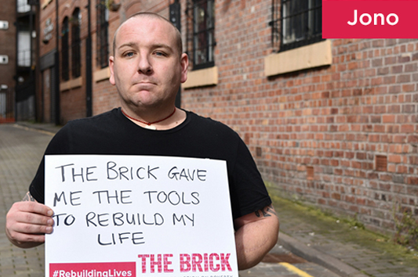

* Firs Lane. Even before The Brick started, one of our priorities was to have our own hostel, so we could offer accommodation. This summer, Firs Lane in Leigh opened. It is a Victorian house that has been completely restructured inside to provide 6 self-contained flats. A historic development.

* Dotties. Emma Holian’s café, Dotties, has been a great addition to The Brickworks, attracting loads of cyclists. And we rejoiced in August as Emma had her own great addition, a lovely baby girl.

* Strategy. The trustees have worked very hard to produce a concise strategy document that will guide our thinking over the next few years.

* Wigan Tenders. Wigan Council put out two tenders for homeless services. The first was to operate many of our services 7 days a week and the second to operate two hubs (night shelters) 7 days per week. Our team, under the skilled supervision of

Louise Green and Simon Dale, worked their socks off to produce excellent tenders and give 2 focussed presentations. With God’s help we were successful. The real work now starts so the contracts can begin on 3rd December.

When I look forward, I see the last 12 months as a period of transition. Why do think this is so? First, the new contact with Wigan Council will change us because we have to grow to fulfil our obligations. Second, there is other stuff in the pipeline. Thirdly, Louise is always full of new, innovative and good ideas.

So, we look forward with great anticipation. My hope is that as well as growing in size we will grow in capability and excel as an organisation. Furthermore, I hope everyone in the organisation will continue to take John Wesley’s maxim to heart and ‘do all the good we can’.

Thank you to everyone involved with The Brick. It has been a great 12 months thanks to your enthusiasm, compassion and commitment.

John

Since December 2017, we have been part of the SIB (Social Impact Bond) as delivery partner for the Wigan borough, alongside Shelter and Great Places, who provide support to individuals in the other Greater Manchester boroughs. The SIB is an ambitious three year programme which aims to support entrenched rough sleepers into long term sustainable accommodation with the offer of wraparound services.

The results so far have been amazing. 68 individuals were referred into the programme and to date:

* 40 have been accommodated in accommodation suitable to their needs
* 20 have successfully sustained their accommodation for 3 months
* 4 have successfully sustained their accommodation for 6 months

The programme isn’t just about finding suitable accommodation. Each individual on the programme works with an Independent Living Mentor, who will guide them towards independence in their homes by providing advice on tenancy matters. Everyone on the programme also has the opportunity to work alongside an Asset Coach, who will help them to achieve their goals and aspirations.

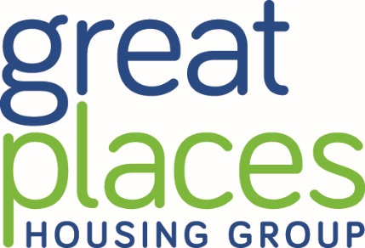

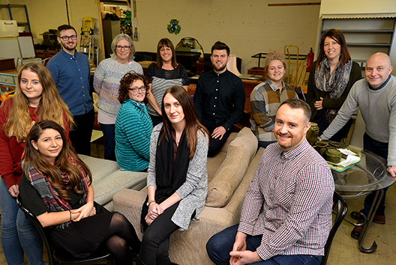

I feel this section is redundant as our volunteers have worked equally as hard and that when I refer to staff and teams, I also refer to volunteers. The only reason I have decided to include this is I feel it is important to highlight that as volunteers, you work incredibly hard out pure dedication and passion. The Brick would not be where it is today without you.

I have pride in where I work and in what I do but what really gives me job satisfaction is watching everyone at The Project constantly going above and beyond and continuing to excel. I hope everyone shares this same sense of pride as what we have achieved this year is nothing short of exceptional. You all motivate me on a daily basis and as a result I strive to want to achieve more. Seeing everyone else efforts and success only motivates me more to want to achieve more and make sure that tomorrow, I achieve more and try harder than I did today. I believe we have created a very solid base in which we can continue to go above and beyond and I can only dream of what we will achieve next year.

The Brick has also seen an increase from 5 emergency bed spaces to 24 alongside 6 supported accommodation units. I would like to thank the No First Night Out team and all staff involved for rising to the challenge and making the transition smooth. I am sure many of you have already received thanks but I would also like to congratulate anyone involved in alleviating or preventing someone from rough sleeping this year. Everyone has done wonderful work and achieved the ultimate goal of putting support in place to make sure the most vulnerable individuals in our community have a safe place to rest and have a stable base to build from.

Further signs of our massive accomplishments this year is our Hospital contract. The service is currently being looked at as a model which could be rolled out across Greater Manchester. During a regional event it was recognised that the Wigan Borough, with support from The Brick, are years ahead of other boroughs in its hospital discharge programme. I owe thanks to Sam and the team who work around the clock and have worked relentlessly to help create a 7 day a week service, boosting The Brick’s reputation even further.

**Business and Finance Director Update**

It’s my role to try to bring in as much money as possible to sustain all this endeavour. The businesses I have met are equally as impressed by the work you do. One international business I met last week after seeing our video with Wigan Athletic said “wow, just wow”. Every day new companies and other organisations are in touch to ask how they can help us.

Our ongoing partnership with Wigan Athletic is now entering its second year. It’s unheard of for a large sporting club to sponsor the same charity two years on the run but they said our relationship was “unfinished business”.

Finally, I would like to say just how humbled I am to be part of this great team and look forward to continuing to get to know you all much better as we work together to change people’s lives.

I started with The Brick 3 months ago and in this short space of time I have been bowled over by the dedication, hard work and selflessness of the staff, volunteers and Trustees at The Brick.

The Brick has always had a fantastic reputation within the Wigan Borough, Greater Manchester and beyond, and I was aware of some of the brilliant and innovative work before I started. However, it is only since joining the organisation that I have been privileged to witness first hand just how hard everyone works to support the most vulnerable people when their lives are in crisis.

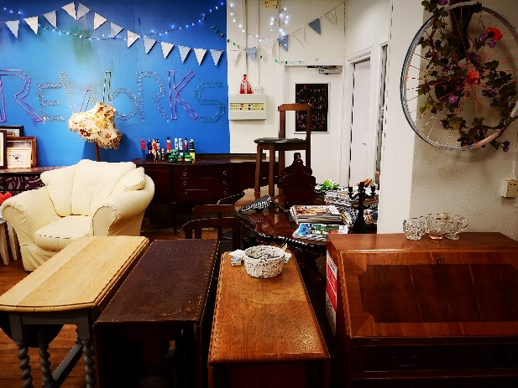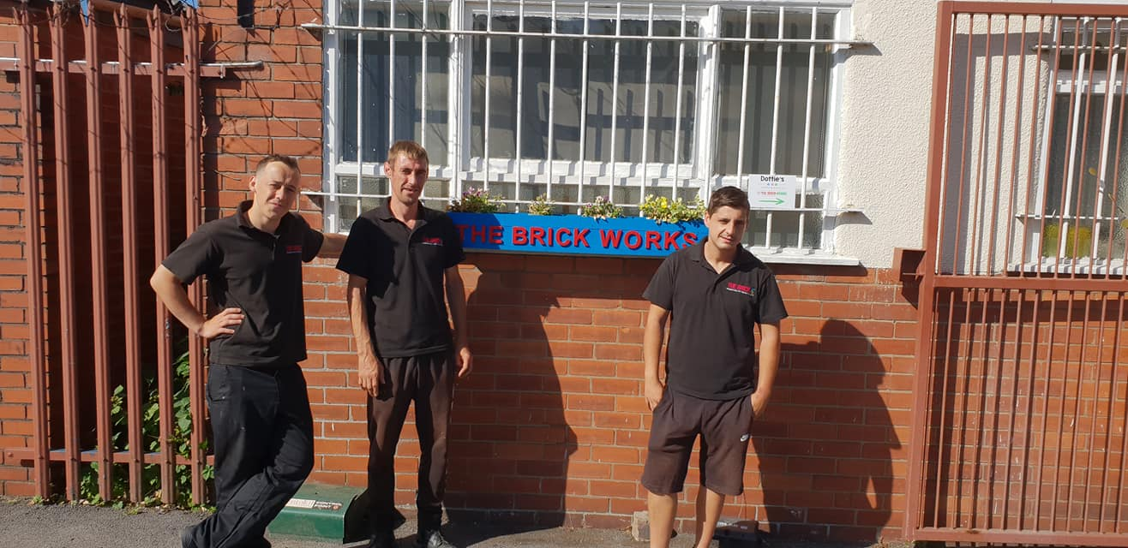

The shop items are donated or sourced from household waste recycling centres across Wigan, showing people the value in discarded items. Volunteers are being recruited to run workshop sessions in make do and mend skills, a sewing room is being planned, and events are scheduled through to next summer supporting different reuse and recycle themes.

Gearing Up in the Brick Works runs bicycle repair workshops and the bike back to work scheme which helps individual who have gained employment have a way to get to work but also encourages an active lifestyle. Six of our trainees are part of our Firs Lane accommodation, Firs lane consists of 6 self-contained flats. While the trainees our accessing the accommodation they get to explore different career paths through training and work experience at a wide variety of organisations.

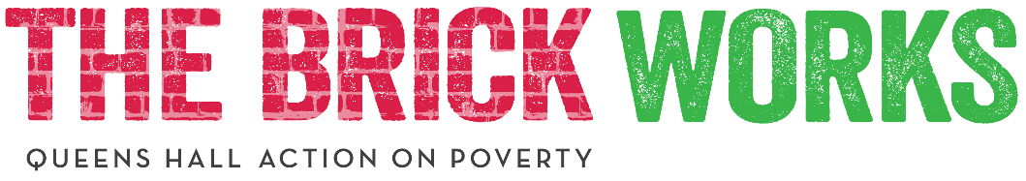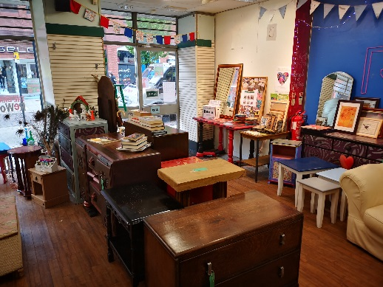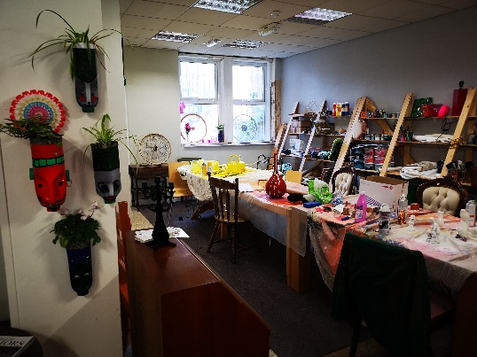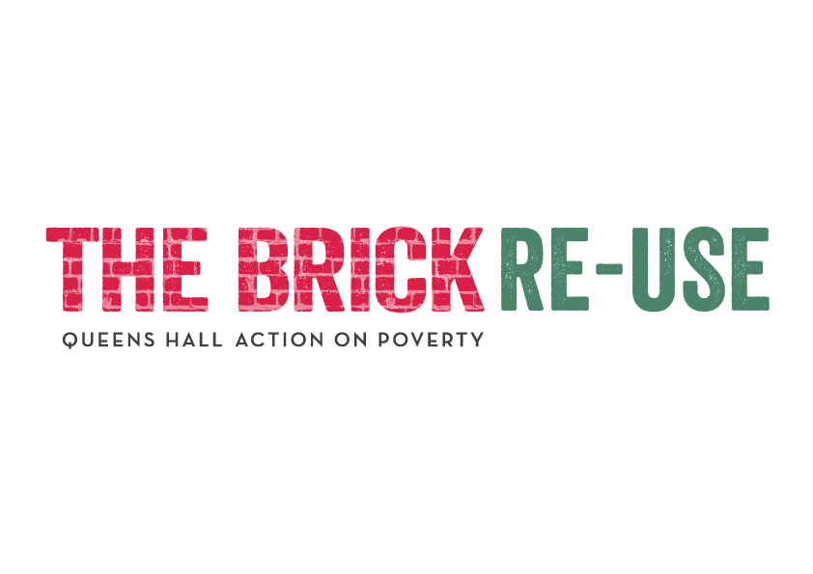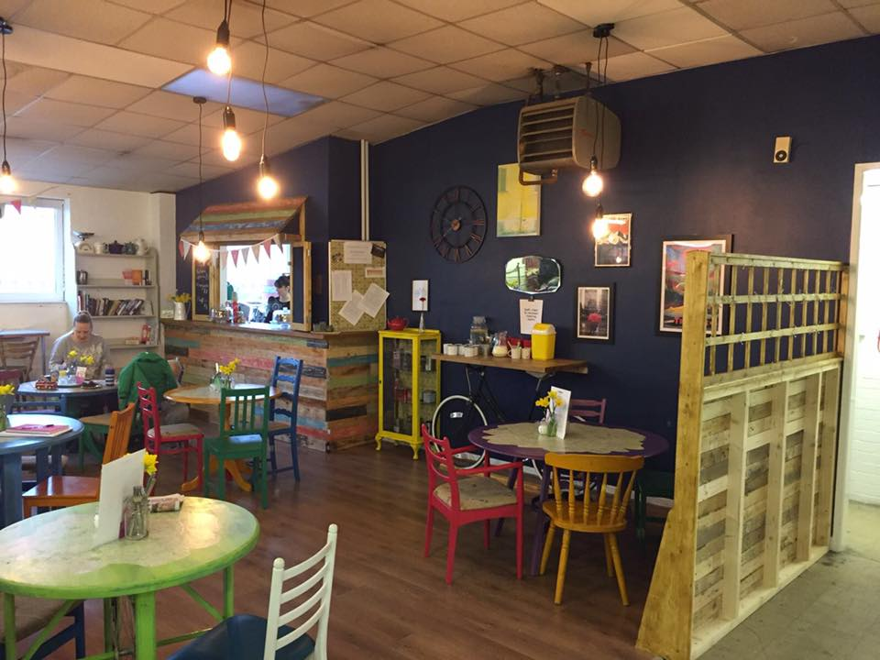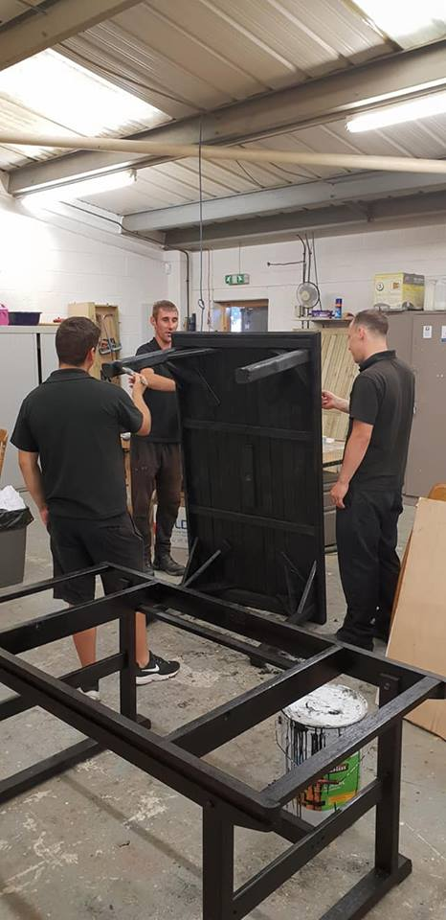

We're able to be working on junk modelling projects and have people come and ask questions while we're working - this is engaging people within the reuse agenda positively, at the same time as raising awareness of the broader charity work.

We've re opened the shop on Market Street, as a showcase for the Reuse and Recycle service. We're able to use the shop to hold drop in sessions so people can have a go at upcycling a piece of furniture free of charge.

One of the Brick Works aim is to help people from all walks of life gain long term permanent employment. To support this aim we have our training programme ‘Steps to Success’, we hope to help trainees gain many qualifications to better chances of employment.

We have several workshops that can help trainees gain and develop skills these include, woodwork, upholstery and upcycling. Located in the Brick Works is our shop that sells but also gives furniture to service users and the general public. Beside the shop is Dotties our café, this is a social enterprise that helps our trainees learn the art of catering and customer service.